Table of Contents

Class 1 2

Class 2 3

Class 3 5

Class 4 7

Class 5 11

Class 6 15

Class 7 19

Class 8 24

Class 9 26

Class 10 31

Class 11 33

Class 12 36

Class 13 38

Class 14 41

Class 15 part 1 41

Class 15 part 2 43

Class 16 Part 1 46

Class 16 Part 2 47

Class 17 Part 1 48

Class 17 Part 2 49

Class 18 Part 1 50

Class 18 Part 2 52

Class 19 Part 1 53

Class 19 Part 2 54

Class 20 58

Class 21 Part 1 60

Class 21 Part 2 62

Class 22 Part 1 63

Class 22 Part 2 65

Class 23 67

Class 24 69

Class 25 72

Class 26 76

## Class 1

What is physiology? What is comparative physiology? What is the distinction between proximate and ultimate causation in physiology? How do we connect basic and applied animal physiology research through case analysis?

* Learning objectives
  + N/A
* Physiology is the study of biological mechanisms at all levels
  + Physiology is about maintaining homeostasis
  + Physiology is constrained to the rules of physics and chemistry
* Comparative physiology studies physiology across different organisms
  + **Krogh’s principle:** for such a large number of problems, there will be some animal of choice, or a few such animals, on which it can be most conveniently studied. Finding the right animal for the job.
  + By comparing strategies among different animals, we can better understand fundamental principles!
  + Comparative physiology allows us to place humans in the tree of life, and understanding our place compared to other animals
  + Two central questions:
    - **Proximate causation:** how do modern-day animals carry out their functions? In other words, the mechanism by which a function is generated
    - **Ultimate causation:** why do modern-day animals possess the mechanisms they do? In other words, the evolutionary origins and pathways that led to a particular mechanism and function
    - Note that these do not necessarily imply each other.
* Basic vs applied research
  + **Basic research**
    - Motivated by curiosity based and interest based scientific questions
    - Justified by the goal of increasing human knowledge and understanding
    - Not driven by a product, process or commercial value of that knowledge
    - The foundation for future applied research
  + **Applied research**
    - Focused on solving existing, human-centric problems
    - Not justified by the pursuit of basic knowledge

## Class 2

How does the body generate fluxes? How does the cell membrane control fluxes?

* Learning objectives
  + Bulk flow and diffusion
  + Brownian motion
  + Fick’s law, aka diffusion in one environment or across a membrane
    - How it relates to diffusion and partition coefficient, permeability constants
  + Transport systems across membranes
    - Simple
    - Facilitated
    - Primary active (pumps)
    - Secondary active (coupled)
* Flux can be generated by bulk flow and diffusion
  + 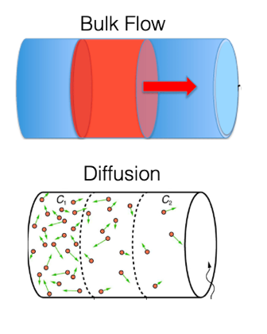
* **Bulk flow:** generated when pressure is applied
* **Diffusion:** generated by random thermo-motion
  + **Brownian motion:** molecules moving in random directions, with a velocity depend on temperature
  + Over time, the molecule goes from one place to another w/ no particular direction. We can calculate net distance by which the molecule moves
  + **Diffusion coefficient:** D = k_B * T / (6*pi*eta*r)
  + **Net displacement:** R_net = sqrt(6*D*t)
    - t is time
    - k_B is Boltzmann constant
    - T is temperature
    - Eta is viscosity
    - r is size of the molecule
  + Basically, these equations tell us that a larger molecule moves slower, a molecule in more viscous fluid moves more slowly, a molecule in a hotter liquid will move faster
  + Using these equations, we see that diffusion over a long distance is extremely slow. This is one of the reasons why we need bulk flow!
  + Net flux: the rate of diffusion of molecules from one point to another
    - **Fick’s law:** Delta J = -(D*A)Delta C/Delta x
      * Delta J is the net flux
      * D is the diffusion coefficient
      * A is the surface area
      * Delta C is the concentration difference
      * Delta x is the distance
    - If we are looking at net flux across a membrane, we can restate this equation
    - **Fick’s law for membranes:** Delta J = -(P*A)Delta C
      * P is the permeability constant, P = (D_m * K_p) /Delta x
      * K_p is the partition coefficient, which describes if a molecule prefers to stay in the water or lipid layer
    - Properties of molecules are encoded into this equation.

|  |  |  |
| --- | --- | --- |
|  | Dm | Kp |
| Hydrophobic | High | High |
| Small, uncharged polar | High | Low |
| Large, uncharged polar | Low | Low |
| Charged ions | High | Very low |

* + - This means that some molecules are not very good at going through a membrane, so we need transport systems.
* Transport systems
  + **Passive transport:** diffusion
    - Simple diffusion if goes directly through membrane, i.e. hydrophobic and small, uncharged polar molecules
    - Facilitated diffusion if needs to go through a protein
      * Large uncharged polar molecules going through transporters
      * Ions through channels
      * Carrier proteins bind to solute whereas channels do not
  + **Active transport:** require energy
    - Pumps, aka primary active transport
    - Coupled transporters, aka secondary active transport

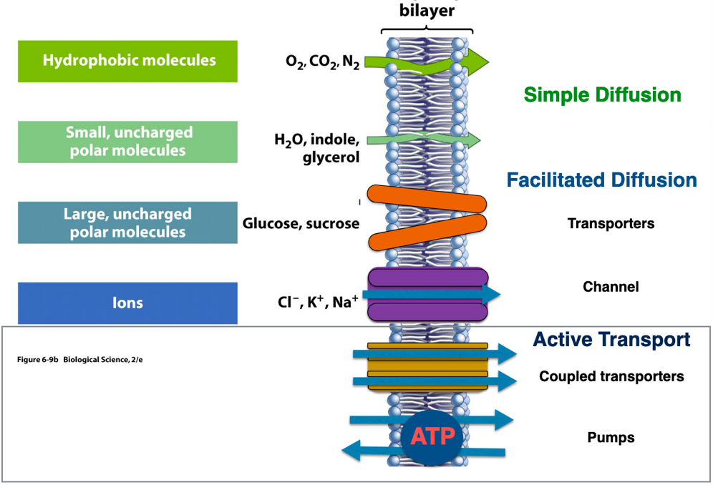

## Class 3

How does the cell membrane control fluxes? How does the body control fluxes of sugar molecules? How are the fluxes through cell membranes combined to form a framework for the treatment of disease?

* Learning objectives
  + Examples of active transport
  + Example of facilitated diffusion vs active transport
* We can simplify an organism’s systems to the interactions between the internal and external environment
  + 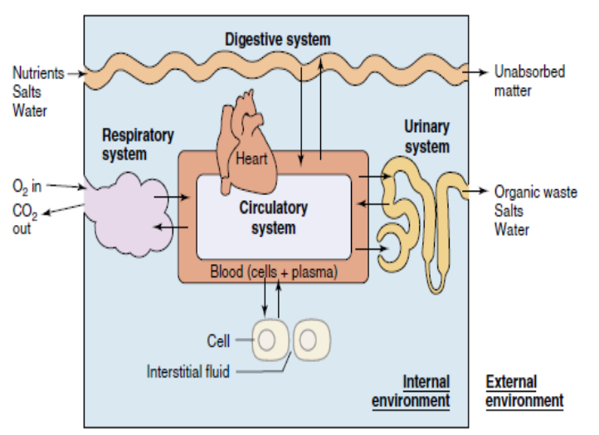
* Epithelial cells interface between internal and external, and use their polarity (asymmetry) to control fluxes
  + 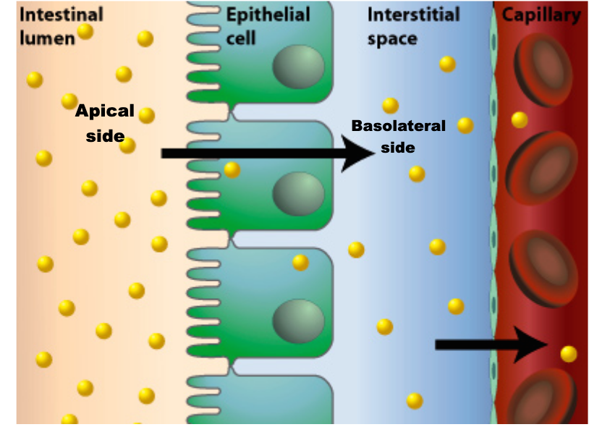
  + **Apical side:** oriented towards the lumen
  + **Basolateral:** oriented away from the lumen
* Controlling fluxes of glucose
  + The intestine must maintain a large flux of glucose from the intestinal lumen to the blood, even if the concentration of glucose in the lumen may be lower than in the blood.
  + In other words, epithelial cells lining the gut need to bring glucose from digestion into the body and must prevent reverse flow of glucose out. We need to make sure that glucose is always flowing in, no matter what the gut concentration of glucose is. This is interesting, because even if the blood glucose is low, you need to bring glucose in against its gradient.
  + On the other hand, most other tissues in your body move glucose by facilitated diffusion (carriers) because the environment is a lot more constant, since it is regulated by the blood (which is normally higher than intracellular concentrations)
  + 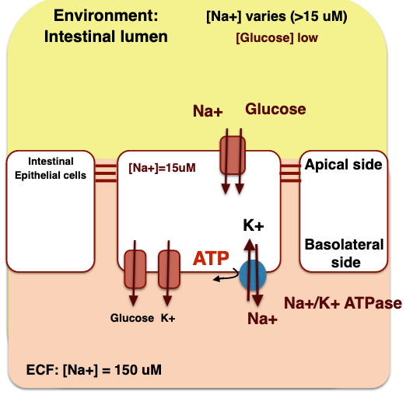
  + While the above diagram is for the intestine, the kidney also uses the same transport system in order to reabsorb glucose from primary urine.

## Class 4

Why do animals need fuels? Why do animals use particular fuels and metabolic processes? How do scientists figure out which energy sources and processes organisms use? What is the relationship between metabolic rate and body size? What is the significance of the quest for a universal scaling law in biology?

* Learning objectives
  + Calories and bomb calorimeter
  + Energy content and energy storage
  + Metabolism and metabolic rate
  + Direct vs indirect calorimeters
  + Measure of energy intake, heat, O2, and CO2
  + Metabolic scaling
  + Debate on universal metabolic allometry
* Animals require energy from the outside, because energy is necessary to create and maintain their essential internal organism
  + Food ultimately becomes CO2, H2O, NH3, heat
* **Calorie:** energetic value of food, measured by heat
* Bomb calorimeter
  + Measures number of calories in food, does so by combusting food and measuring the heat released
  + Energy held in the food gets released by combustion, energy gets transferred into water, and we measure the change in temperature of the water
* Difference between fuels in energy
  + Carbohydrates are partially oxidized, hydrocarbons are unoxidized, so hydrocarbons will produce more energy
  + Carbs go through anaerobic (glycolysis) and aerobic (oxidative phosphorylation) ATP generating steps, so are a good rapid, anaerobic option
    - Anaerobic metabolism requires regeneration of electron transporters
    - Gluconeogenesis is used to convert lactic acid into glucose, and requires energy, so being anaerobic all the time is expensive
  + Fats go through only aerobic generating step
  + In other words, carbs are the fuel of choice for rapid and anaerobic activities, while fats are more efficient but require always aerobic reactions
  + Phosphagens can provide a reserve of chemical energy in the form of high-energy phosphate bonds
  + Fats are primary fuel source for most tissues (except brain)
* Difference between fuels for storage
  + Carbohydrates are very polar, must be surrounded in a lot of water, which adds a lot of weight
  + Fats are hydrophobic, no water needed for storage
  + Animals take this into consideration. For example, clams are in the water, they don’t really care about weight, and are often in low oxygen (hypoxic) situations, so carbs are a good choice. Geese need to be light to fly and are better suited for fats.
* Metabolism: how cells utilize the energy absorbed from food during digestion (rate of energy expenditure)
  + Can be approximated by ATP turnover… which can be further approximated by O2 consumption
* Measuring metabolism
  + There are a few reasons for measuring metabolism
    - Determine how much food an organism needs
    - Determine intensity of living, level of physiological action
    - Determine how fast an animal will drain its ecosystem
  + 1) Calculate the difference between energy taken in vs excreted. Flaws:
    - Growing organisms
    - Organisms might store some of the energy rather than use it
  + 2) Lavoisier direct calorimeter: put organism in ice, heat from metabolism melts the ice. This measures heat produced by chemical reactions and heat capacity. Flaws:
    - You need to account for heating of food, water vaporization, external movements of materials (like potential energy)
  + 3) Measure oxygen used, since heat produced per liter O2 is fairly consistent. Flaws:
    - Tthis doesn’t measure anaerobic activity by the organism or gut microbe
  + 4) Measure respiratory quotient (RQ), which is amount of CO2 eliminated / O2 consumed. This would allow us to infer what type of fuel is used (carbohydrate vs lipids). To estimate relative protein metabolism, we could measure nitrogen excretion via urea or uric acid. Flaws:
    - CO2 can be produced w/o metabolism (hyperventilating, lactic acid and pH rebalancing)
    - Different food sources yield different amounts of CO2
* **Basal metabolic rate:** metabolic rate of a homeotherm while in its normal temperature range (thermoneutral zone), fasting and resting (not sleeping)
* **Standard metabolic rate:** metabolic rate of an ectotherm while resting and fasting
* Basal metabolic rate increases with weight. Not linearly, but allometrically
  + M = aW^b
  + M is metabolic rate
  + W is body weight
  + a and b are constants, b<1, a can be any value
  + 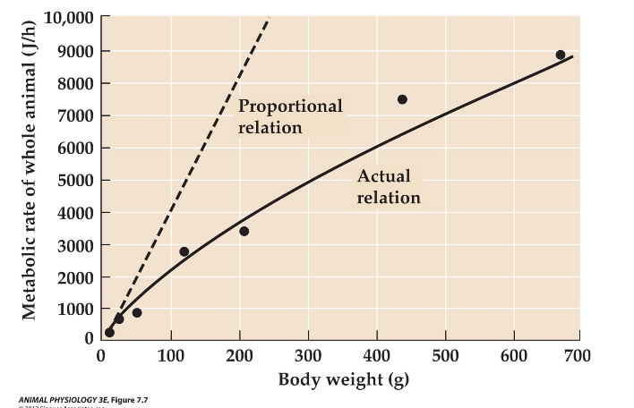
* **Weight-specific metabolic rate:** metabolic rate per unit of body weight, and decreases with weight
  + The smaller you are the faster you burn per gram of body weight
  + 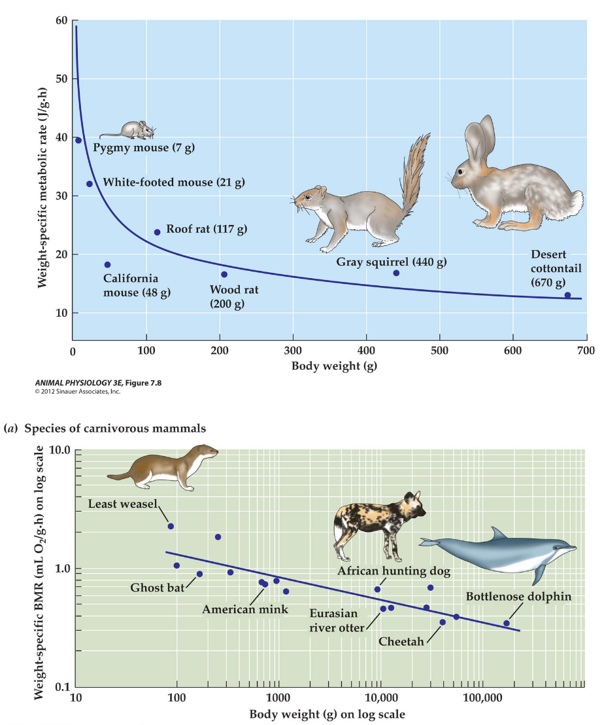
* **Universal scaling law:** different types of vertebrates follow different curves, but they all follow the same allometric pattern
  + One possible explanation could be that bigger animals have more volume than surface area (low SA to V ratio), so they lose relatively less heat than their smaller counterparts, so their metabolism is less
  + Another possible explanation is based on ecology and food assumption, in the sense that herbivores of different body sizes coexist in the same ecosystem, and their population biomass can be considered a function of body size. This means that bigger animals eat less relative to their size, so their metabolism is less per weight
  + Respiratory and circulatory physiology also allometrically related to body size w/in a set of related species. Small species require more O2 per gram of body weight, but their hearts and lungs are no bigger relative to body size. Small animals breath faster and their heart beats faster
* Allometric metabolism to size relationship occurs in part by geometrically imposed constraints
  + Fractal geometry of circulatory systems allow organisms to scale up

## Class 5

What is the effect of temperature on metabolic processes? What is the significance of a performance curve, and how do they give insight into the effects of temperature w/in and across species? Why are some animals in equilibrium with their environment while others aren’t? What is the physics of heat gain, loss, and storage? What are the strategies of meeting environmental challenges? Who is Knut Schmidt Nielson and what were his contributions?

* Learning objectives
  + Pejus range
  + Upper critical temperature and lower critical temperature
  + Connection with climate change
  + Q10
  + Temperature sensitivity of enzyme activity and membrane viscosity
  + Difference between acclimation and adaptation
  + Poikilotherms vs homeotherms
  + Endotherms vs ectotherms
  + Heat balance equation
  + Conduction, convection, radiation, evaporation
  + Insulation, huddling, shunting, changing surface area
* Metabolism depends on temperature, so any process that depends on metabolic energy will vary with temperature.
* Q10: measure of sensitivity of a life process to temperature, change in metabolic rate caused by an increase of T of 10C. This term can be used for all rate processes affected by temperature.
* Temperature-performance curve
  + Basically, as we vary temperature, we can measure physiological performance, and this can be used as indirect measures of fitness (the ability for an organism to respond to environmental variation)
  + Aerobic scope: peak rate of O2 during exercise/resting O2 consumption­. Basically, measures performance.
  + Pejus range: temperature range when performance begins to decline, but not as severe as critical limits. This range allows us to study metabolically stressful but not harmful changes in environment
  + Critical limits: temperatures beyond which only short-term exposure is possible
  + LT50: temperatures lethal to 50% of experimental subjects
  + 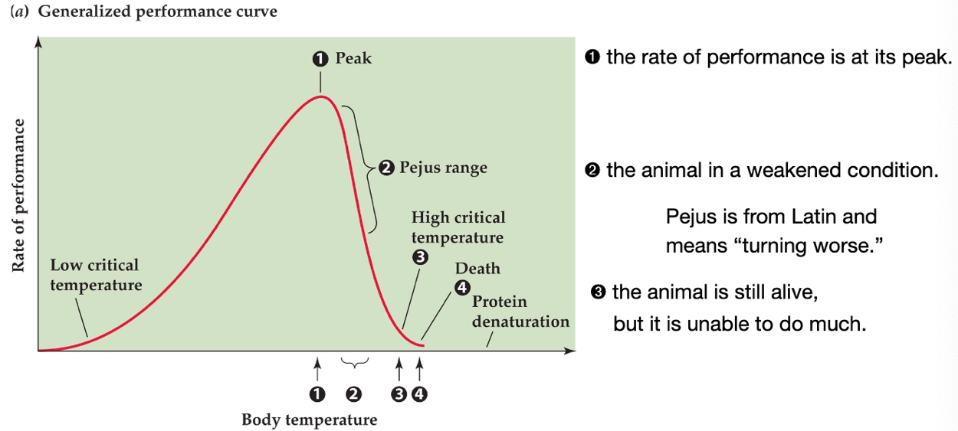
  + 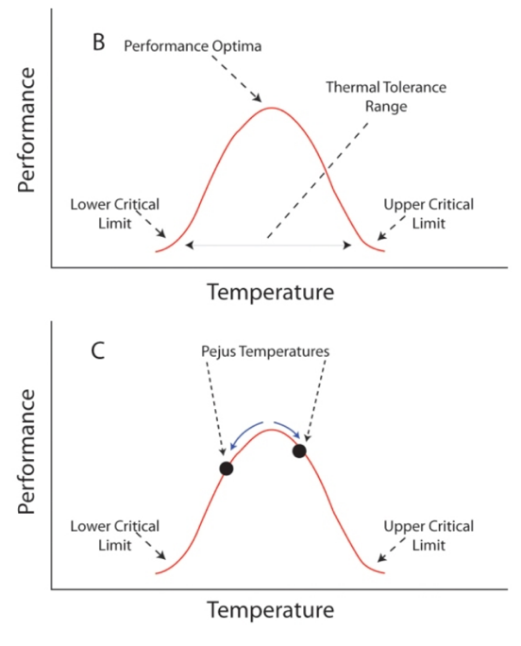
* Example of why performance curves are useful
  + Performance curves can tell us what will happen to animals if their habitat gets hotter due to global warming. Some organisms might get improve performance, but some might cross a threshold, and performance will decrease.
  + 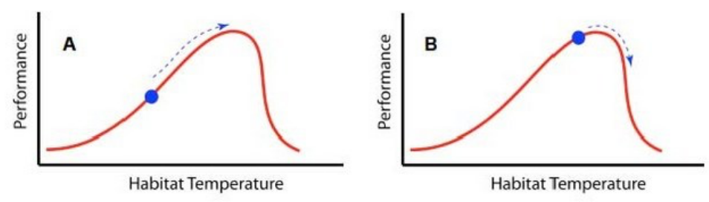
* Possible explanations of performance distribution
  + Enzymes are temperature sensitive, and this affects performance
    - Comparing lizards in different parts of the world, we can see that optimum temperature is an evolved trait based on environment. Peak can be shifted left or right.
    - Animals living in variable environments need to be able to have good performance at multiple temperatures, compared to animals living in more constant environments.
    - Acclimation: physiological changes due to change in animal’s natural setting.
    - Enzymes within an animal can acclimate to the environment.
  + Membrane viscosity is temperature sensitive
    - At higher temperatures, lipid bilayer is not stable.
    - Homeoviscous adaptation: Adaptation of cell membrane lipid composition to maintain adequate fluidity. Having more saturated/unsaturated hydrocarbons can help animals adapt.
    - Regional heterothermy: maintain different temperature zones in different regions in the body.
    - An example of homeoviscous adaptation w/in an organism is moose or elk that step in snow, their lipid bilayer composition will be diff at their feet (cold) vs their body (warm)
* Thermal classification
  + 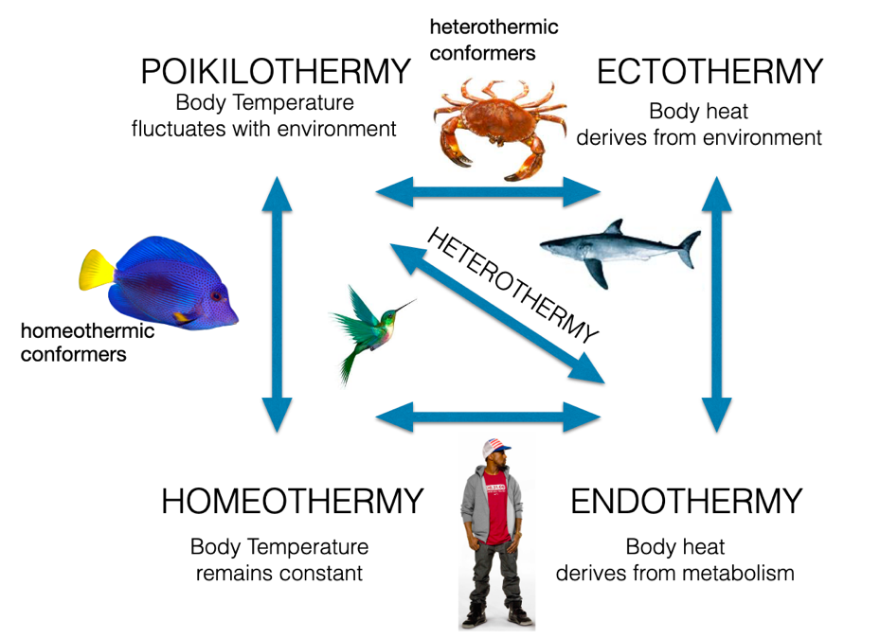
  + Animals may be classified into one or another, or they might fit into multiple categories.
  + Endotherms have thermoneutral zone in performance optima range.
  + Ectotherms do not have thermoneutral zone, but do have range of temperatures where they are most metabolically efficient
  + 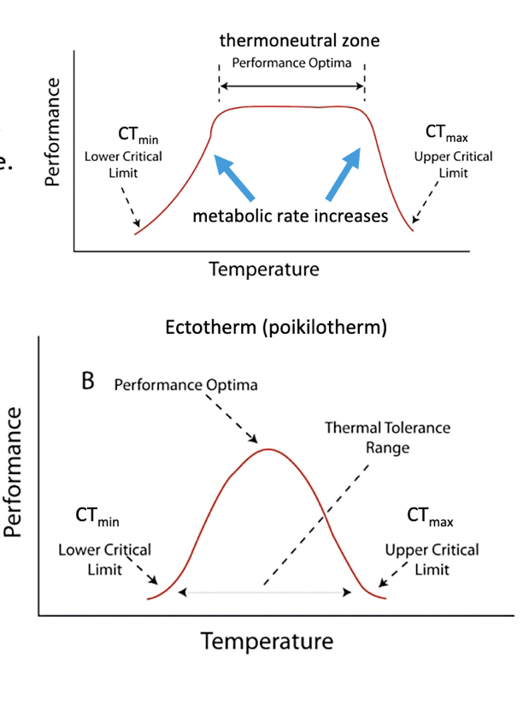
* Heat transfer mechanisms
  + Radiation (in or out)
  + Conduction (in or out)
  + Convection (in or out)
  + Evaporation (always out)
  + Heat balance equation: Total metabolic production heat (Htot) is sum of various heat loss or exchange
    - Htot = Hc + Hr + He + Hs
    - Hc is conductive and convective, + when net loss
    - Hr is radiation, + when net loss
    - He is evaporative, + when net loss
    - Hs is storage, + when net gain by body
  + Examining contributions of these factors pinpoints specific thermal strategies in particular species.
* Heat flux by conduction/diffusion
  + J = (K*A)Delta T(env-body) / Delta x
    - K is thermal conductivity
    - A is area
    - Delta T(env-body) is difference in temperature between environment and body
    - Delta x is distance between body and environment, the size of unstirred layer
  + Heat diffuses like chemicals, so we can adapt flux equation for it.
  + If air is stirred, this is like bulk flow.
* Keeping animals warm:
  + Insulation: create a layer of unstirred air, increase Delta x. I.e. feathers, blubber
  + Shunting: vasoconstrict blood vessels closer to skin, increase Delta x.
  + Huddling/curling up: decrease surface area of organism or population exposed to air
  + Thermogenesis: metabolic heat production. Shivering can produce heat. Nonshivering thermogenesis via brown fat in mammals or muscle heater in birds and tuna
* Keeping cool:
  + Adaptation to body size: animals can vary their surface area/volume ratio, increase A. I.e. jackrabbits have big ears
  + Insulation: reduces heat flux in both ways, so it can keep hot air away, increasing Delta x.
  + Evaporation: Panting, sweating.

## Class 6

What are the key molecules involved in movement? How is movement variability achieved through variations of behavior, chemistry, and organization of these molecules? How do permeability and ion concentration guide and control muscle contractions?

* Learning objectives
  + Actin and myosin organized in sarcomeres
  + Cross bridges and power strokes in actin myosin cycling
  + Role of calcium ion in
    - Regulation of troponin complex
    - Excitation at neuromuscular junction
    - Excitation contraction coupling
  + Number of cross bridge formation, sarcomeres in series vs parallel
  + Duration of cross bridge formation
    - Myosin head isoforms
    - ATPase activity
    - Troponin complex with increased Ca+ activity.
* 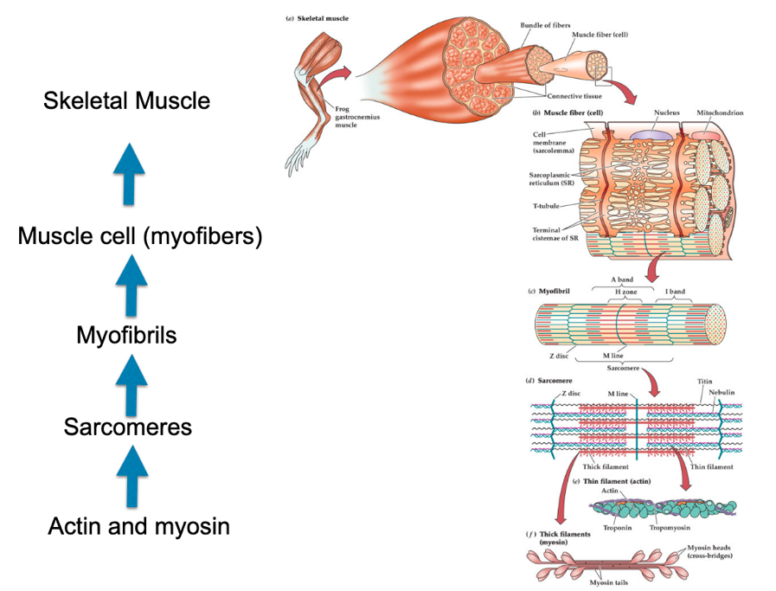
* Molecular basis of movement
  + Actin (thin) filament made up of globular actins
  + Myosin (thick) filament made up of two bouquets of myosin
  + Myosin has ATPase at its head, transduces ATP hydrolysis into movement
  + Power stroke
* Striated muscle has organized actin and myosin in sarcomere units
  + 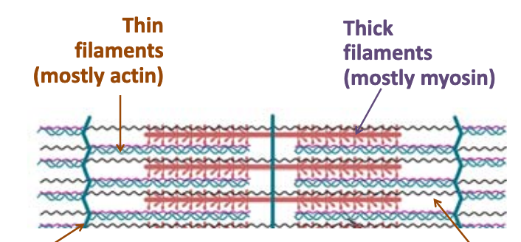
  + Sliding filament theory: sliding of actin past myosin generates muscle tension. Because actin is tethered to structures located at lateral ends of z bands, any shortening of the actin filament length would result in a shortening of sarcomere and thus muscle
  + Because of bipolar organization of myosin filaments, when they pull on actin filaments, they shorten the sarcomere.
  + 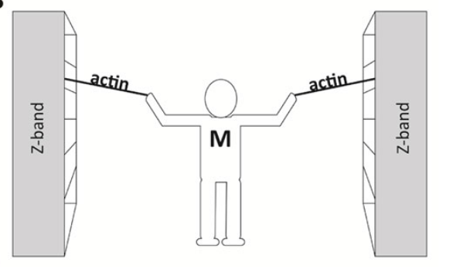
* Cross cycling
  + 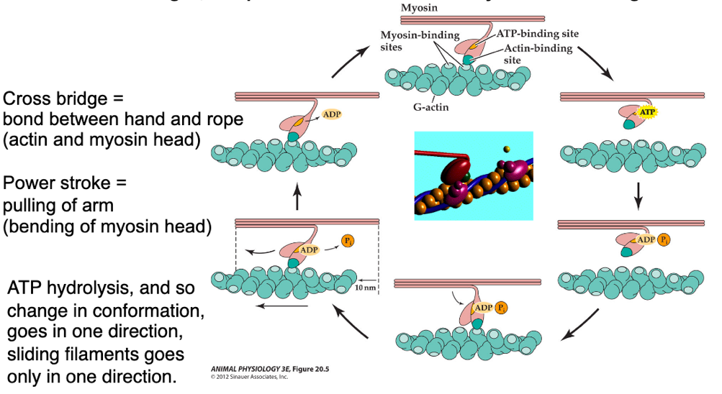
  + ATP is needed to break cross bridges and allow myosin to reach forward and grab again. Without ATP, myosin stays bound to actin, causing stiffness
* Role of calcium in sarcomere shortening
  + Tropomyosin: thin proteins that wrap actin
  + Troponin: small proteins connected to each other and have binding sites for calcium ions
  + Troponin and tropomyosin together form troponin complex
  + Calcium is required by troponin complex to regulate cross bridge formation between myosin and actin. Calcium exposes myosin binding sites
  + 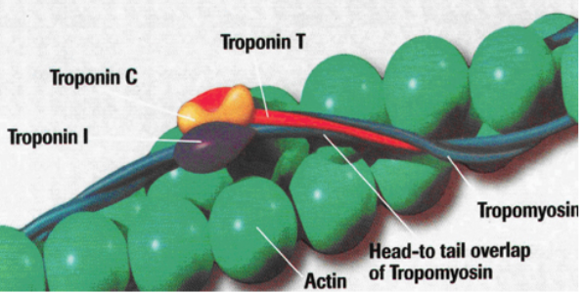
  + In the absence of calcium, binding does not occur
* Neuromuscular junction: connection between axon terminal and muscle fiber where stimulation of muscle cell to contract occurs. Calcium is also needed in this step, to tell muscle to contract.
* Excitation contraction coupling: because calcium regulates muscle contraction and excitation, it links these two processes together.
  + Achieved by transverse tubules (t-tubules) and sarcoplasmic reticulum (SR)
  + Protein regulates the amount of calcium in muscle at a given time, lets calcium go in and out.
  + 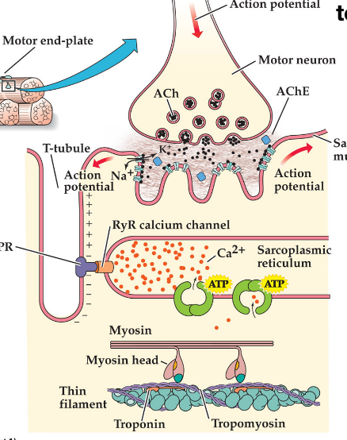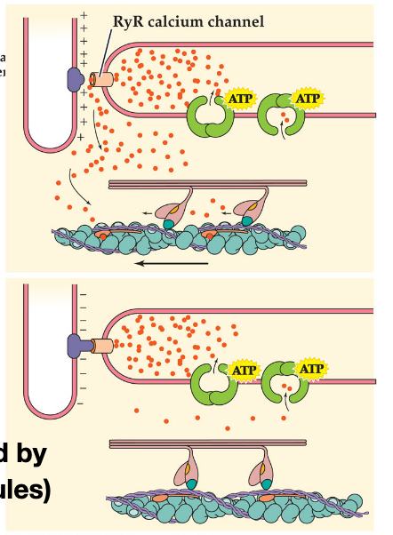
* Changing duration and force of muscle contractions
  + Increase the number of cross-bridges (number of sarcomeres)
    - Assume that length of sarcomere cannot be changed, and that velocity of sarcomeres are constant.
    - Add them in parallel, increases muscle strength, which scales with cross-sectional area
    - Add them in series, increase velocity of contraction
    - Say that we can change the length of sarcomeres, a long sarcomere would have every cross bridge pulling on the load, and you could move a large load (large load, small velocity). If we increase have short sarcomeres in series, we reduce the cross-bridges pulling on the load, but we move it further (small load, large velocity).
  + Vary duration of cross-bridge formation
    - Use different myosin head isoforms. Cardiac isoforms have faster ATPase action, faster contractions, higher rates of force development.
    - Alternatively, increase rate of phosphate release, decrease rate of ADP release to increase rate of force development and total number of cross-bridges per time
    - Change affinity to calcium ions. If troponin complex binds calcium ions more quickly and at lower concentrations, contraction happens more quickly (i.e. fast twitch, sprinting muscles)
  + Other considerations
    - Temperature
    - pH
    - Muscle troponin isoforms in fetuses
    - Skeletal muscle vs smooth muscle
    - 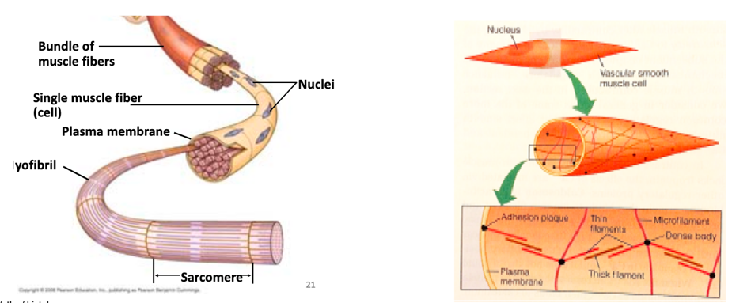
* Evolution
  + At least two independent evolutionary origins

## Class 7

How is muscle performance experimentally tested and analyzed? What underlying mechanisms explain isotonic and isometric contractions and the tradeoff between force and speed? What tricks do animals use for extremely rapid or long duration muscle contractions?

* Learning objectives
  + Define motor unit
  + Different ways to stimulate a muscle
  + Different responses of muscle to stimuli
  + Quantification of force produced by muscle
  + Quantification of change in length of muscle after contraction
  + Significance of relationship between velocity of shortening and force of load
  + Significance of relationship between force of load and work, and load and power
* Stimulating a muscle
  + Electrical stimulus on muscle, on motor neuron
  + Modify Ca+, add neurotransmitters (acetylcholine)
* Force transducer: device that measures tension produced by a muscle contraction
  + Tension is a pulling force
* There are different ways to stimulate muscle fibers, and different responses of muscles to electrical stimuli
  + Contractions can be graded from single twitch through a tetanic contraction depending on the frequency of impulses received
  + In a single twitch, there is a single stimulus, which causes a single contraction and relaxation
  + In temporal summation, there are multiple stimuli, which cause multiple contractions and relaxations, with a gradual increase in tension, followed by relaxation
  + In fused/complete tetanus, there are many stimuli, and a large increase in tension and relaxation
  + 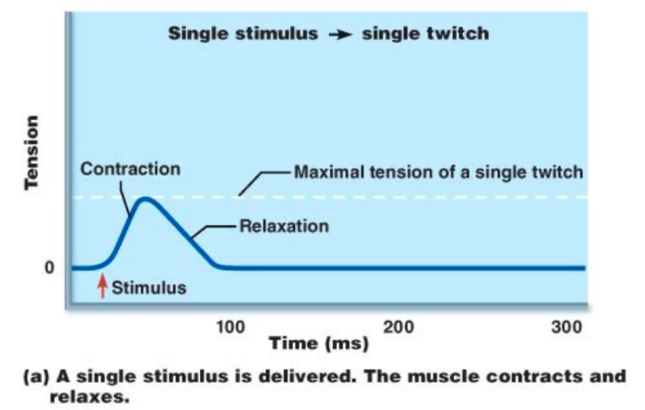
  + 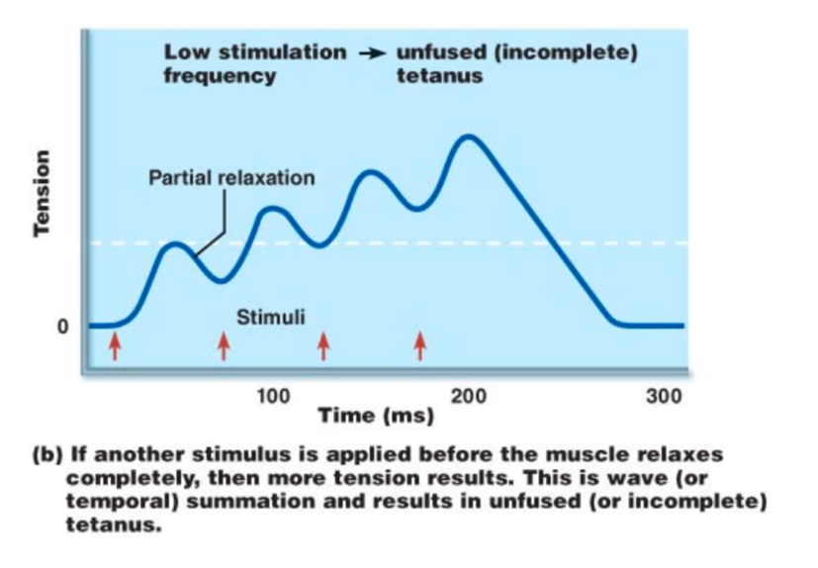
  + ­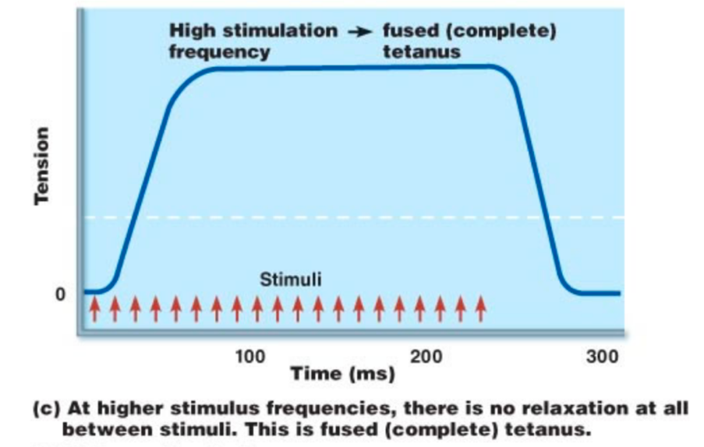
* A motor unit is a motor neuron and skeletal muscle fibers innervated by that motor neuron. Basically, muscle fibers innervated by the same neuron.
  + For more delicate movements that require precision but little force, small motor units are recruited.
  + For performing gross motor movements involving a lot of force, larger motor units are recruited.
  + Small motor neurons are more excitable, so they are recruited first
  + Contractions of increasing strength occur through progressive recruiting of larger and larger motor units.
* Graded muscle response can also change as a function of myosin/actin overlapping, highlighting an application of the length-tension relationship at a sarcomere level.
  + If you plot tension developed upon stimulation based on sarcomere length, you get a curve showing that there is an optimal amount of overlap that produces the most tension.
  + In other words, there is the right amount of overlap to produce pull, and there is not so much overlap that there is little to go.
  + 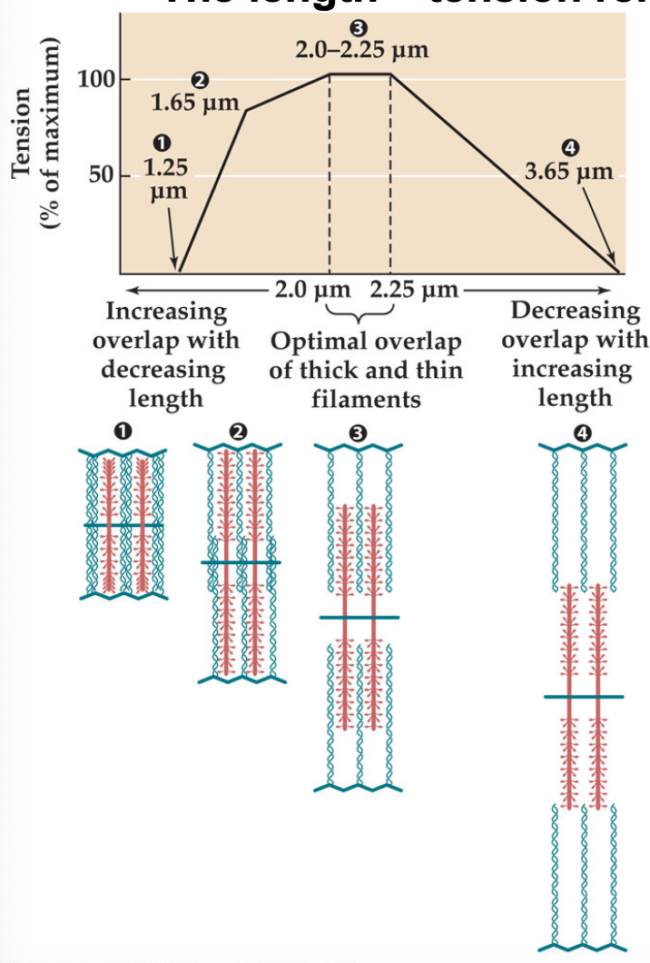
  + Animals can adjust muscle tension to start contractions at varying points on this curve, i.e. a jumping frog or sprinter in pre-stretch position.
* Measuring force created by muscle by holding length of muscle constant (isometric contraction) to get force/tension on its own
  + 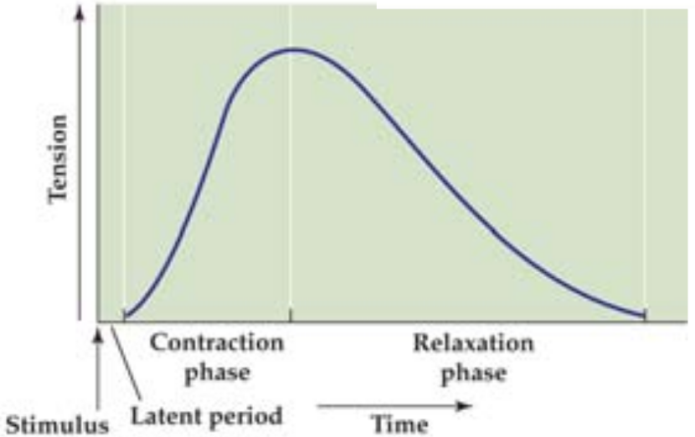
* Measuring length of contraction by holding tension constant (isotonic contraction) to get distance of muscle contraction on its own
  + 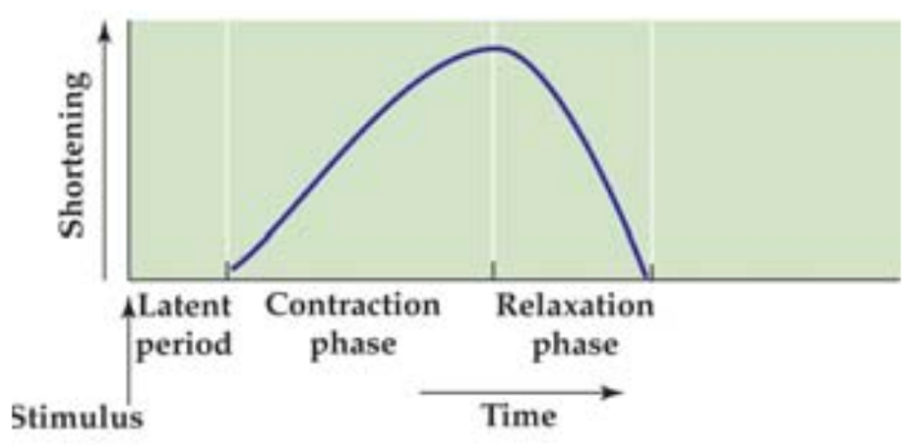
* The length-tension relationship can be demonstrated at the muscle level
  + The force is of the load being picked up. At no load, the distance will be large (a bicep curl with no weight). At high load, the distance will be small (imagine something you can’t pick up).
  + 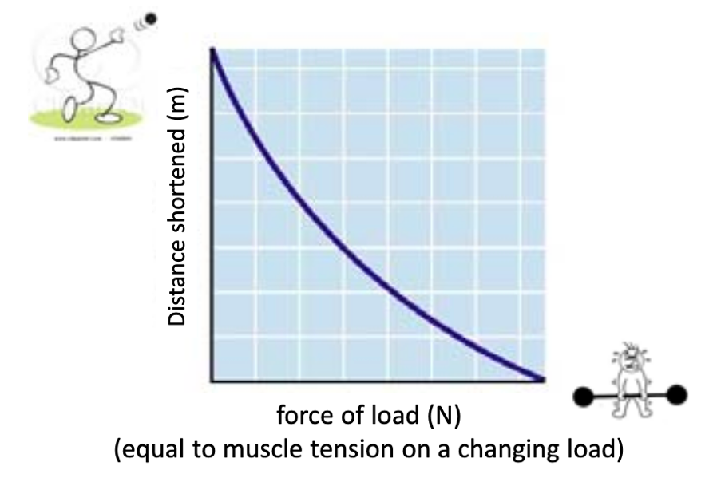
  + Distance shortened is sort of synonymous to velocity.
* Physiological basis for force-velocity relationship
  + Force generated by muscle depends on the number of cross-bridges attached
  + Because it takes a finite amount of time for cross-bridges to attach, filaments slide past one another faster and faster
  + The force decreases due to the lower number of cross-bridges attached
  + Conversely, as the relative filament velocity decreases, more cross-bridges have time to attach and to generate force, and thus force decreases.
* If we multiply force by distance shortened, we get work. We can plot the work based on the size (force) of the load
  + 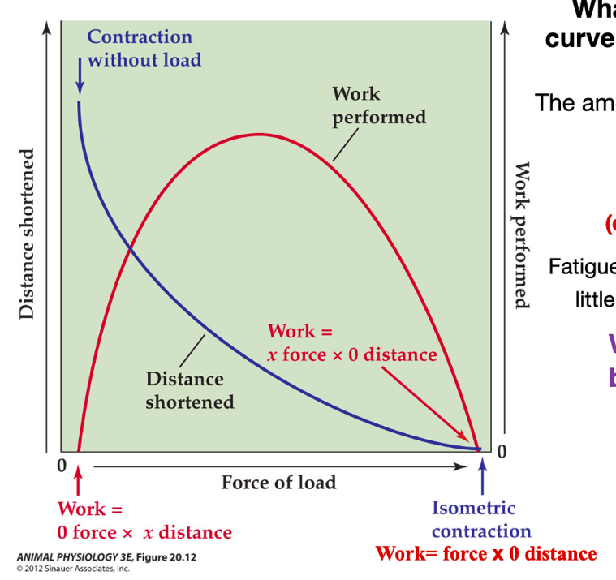
  + This indicates that work is maximized at a certain load. At extremes (no load, extremely heavy load), no work is performed.
  + In addition, fatigue is a reflection of working inefficiently, little work for a lot of energy consumed
* Power = W / t = F * v, which is similar to force * distance. We can plot force-power, but it doesn’t tell us anything significantly different.

## Class 8

How does muscle performance vary across individuals over time? How do animals maximize power with muscle? How do animals circumvent muscle limitations to achieve power amplification?

* Learning objectives
  + Enhancing performance through exercise
    - Muscle fiber types
    - Endurance vs resistance training
    - Fatigue
    - Repair
  + Power enhancement through sarcomere manipulations
    - Power = force times velocity
    - Frog jumping
  + Extreme power output in animals
    - Mantis shrimp
    - Trap jaw ants
  + Synchronous vs asynchronous muscles
* Power = W/t, so powerful contractions maximize work, minimize time, or both.
* Animals have synchronous and asynchronous adaptations to get extremely fast contractions (minimize time).
  + Synchronous means that muscle contraction is synchronized w/ action potential that initiated it.
  + Asynchronous means that individual contractions are not synchronized w/ individual nerve action potentials. This can be faster if you can provide many contractions per action potential. They can provide greater power output and can be more efficient than synchronous. A lot of insects are async.
* Synchronous
  + Ca2+ flow
    - Large SR that permits fast flooding of calcium ions
    - Fast release of Ca2+ from troponin
    - Fast uptake of Ca2+ by SR
  + Cross-bridge cycling
    - Rate limiting step is detachment of myosin from actin, so detaching fast
  + Sarcomere itself
    - Normally, sarcomere shortening is limited by Z disks, have perforations that allow thick filaments to shorten even further to allow for more distance can give high speed contractions
* Asynchronous
  + Low rates of Ca2+
  + Low investment of SR
  + Low energy expenditure
  + More volume to allocate myofibrils
* Animals can modify their muscular system to maximize work.
  + Shelled organisms (clams?) use catch muscles to keep their shell closed for a long time and use low energy
  + Myosin is directly regulated by Ca2+ ions
  + Muscle remains contracted even in absence of calcium ions
  + Use a protein called twitchin that keeps dephosphorylating during contraction
  + Muscle only relaxes when serotonin is released, activates PKA, which phosphorylates twitchin and causes system to relax
* Another way to improve efficiency of a muscular system is to have different types of fibers with different contractile capabilities
  + Slow oxidative
  + Fast oxidative glycolytic
  + Fast glycolytic
  + These muscle types differ in energy usage, and have different molecular isoforms of the myosin heavy chain and Ca2+ ATPase pump in SR
  + This composition may change over time
  + Some people might have genetic basis to their fiber type proportions, i.e. swimmers with more fast fibers and endurance with more slow fibers in thigh
  + Fiber composition may also change in response to functional demand. That being said, you can’t change the number of muscle cells
* If you can’t change the number of muscle cells, how can you improve muscles?
  + Aerobic, endurance exercise
    - Increase capillary growth around muscles (angiogenesis)
    - Increase amount of mitochondria
    - Small shifts in muscle fiber type
  + Resistance training
    - No improvement of aerobic capacity
    - No capillary growth
    - No additional mitochondria
    - Hypertophy, which increases the size of cells due to more actin and myosin myofibrils, fusion with neighboring satellite cells to get more nuclei for larger cells
    - Small shifts in fiber type
    - Shifts in some myosin isoforms
* Muscle repair, response, and development
  + Satellite cells (muscle precursor cells) hold 5% of muscle cell nuclei and are attached to surface of myofibers
  + When muscles are damaged, they release chemicals that trigger the satellite cell to migrate to the chemical source
  + Myogenesis occurs and the satellite cells either fuse with existing myoblasts (myocyte precursor) or create new ones
* Muscle fatigue
  + Typically attributed by lactic acid buildup and low pH
  + Is fatigue necessarily a bad thing? Not necessarily, it can prevent an animal from damaging their body, by causing the animal to stop
  + Lactic acid and pH are likely not the direct causes of muscle fatigue, but are good proxies for fatigue
  + Fatigue is most likely caused by inadequate muscle glucose and accumulation of ions in the wrong places (such as Ca2+)
* Power amplification: increase power past muscle’s limits, created by minimizing time or maximizing work, or both
  + Trapjaw ants and mantis shrimp are examples of spring-loaded sort of mechanisms
  + Learning about other organisms’ power amplification techniques can create space for biomimicry research

## Class 9

How do ion fluxes generate and maintain the membrane potential? How do neurons alter the membrane potential for signal transduction? How do analogies to electrical wires inform understanding and analysis of neural signaling?

* Learning objectives
  + Nernst equilibrium potential
  + Goldman Hodgkin Kats potential
  + Graded potential
  + Action potential
  + How permeability of membrane generates and propagates action potential
  + Size and insulation to optimize propagation of signal
* Chemical potential difference
  + 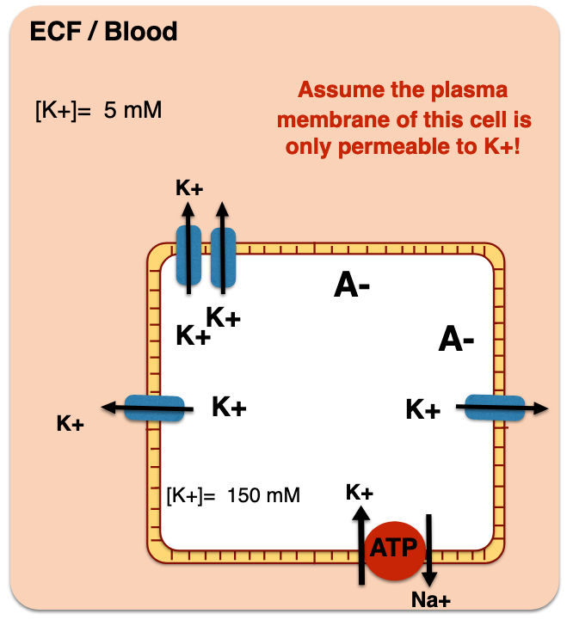
  + Na+/K+ ATPase pump generates a concentration gradient
  + Concentration gradients are potential energy (free energy!) that can drive other solutes to move against their concentration gradient
* Electrical potential difference
  + When an ion moves, electrical potential energy is created in addition to chemical.
  + There is net movement of K+ outside, leaving negative anions inside
* Membrane potential equilibrium
  + A membrane is at equilibrium when [K]in = [K]out.
  + Equilibrium potential for K+ is reached when there is almost no difference of ion concentration on the two sides of the membrane
* Nernst equilibrium potential for single ions
  + For an ion,
  + We know that Delta G conc = RTln(Coutside) – RTln(Cinside) = RTln(Cout/Cin)
  + We know that Delta G elec = Welec = -zEF
    - Z is charge (an integer)
    - E is electric field
    - F is a constant
  + At equilibrium, we know that Delta G = Delta G conc + Delta G elec, and Delta G = 0. Thus, Delta G conc = -Delta G elec, or zEF = -RTln(Cin/Cout)
  + Thus,
  + Eequil = -RT/zF ln(Cin/Cout)
  + If K+ is the only ion moving, the membrane potential would be mostly equal to the equilibrium potential for K+
* Goldman Hodgkin Kats potential for multiple ions
  + 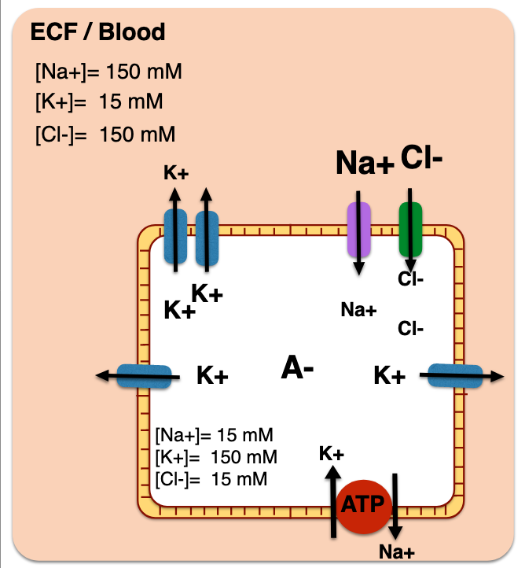
  + Membrane potential depends on flux of all ions
  + E = -RT/F ln (sum of P_i [i]in / sum of P_i [i]out)
    - P is the relative permeability
  + Cells are dominated by K+ leaks and therefore there is a negative membrane potential.
  + We can expect an E not as negative as the equilibrium of K+ because the influx of Na+ makes the Em more positive
  + Based on this formula, we see that the resting potential depends on its permeability to different ions
  + If the permeability changes, the membrane potential changes
  + In addition, only a small number of negative and positive ions need to be separated by a membrane to create the resting membrane potential, and ICF concentrations of Na+ and K+ do not change much.
* Measuring membrane potential
  + Voltmeter in parallel
* Graded potential
  + Electrical stimulus will open Na+ channels. Like charges repel, it will push K+ away and out of the cell through leaky K+ channels, propagating the membrane potential
  + The magnitude of change in potential depends on the strength of the stimulus
  + This is fast but does not spread over long distances (exponentially decreases with distance)
  + 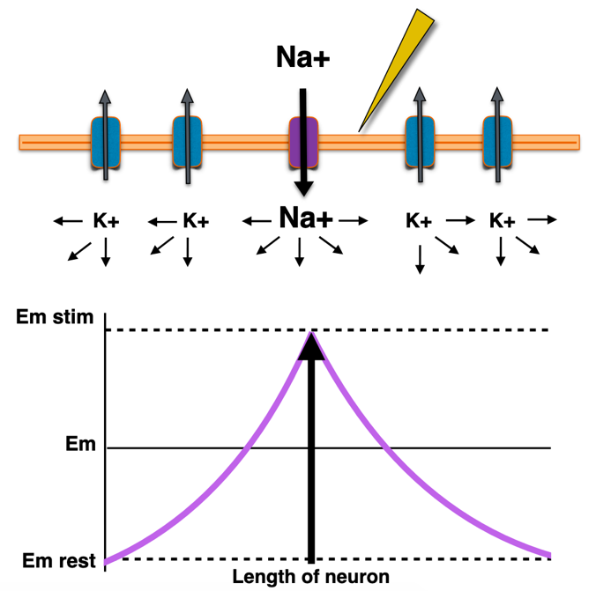
* Action potential
  + VGNaC are triggered when there is a change in depolarization.
  + Local depolarization of membrane opens voltage gated sodium channel (VGNaC), causing inward flow of Na+ ions
  + Like charges still repel, so Na+ pushes other Na+ outwards
  + The flow of ions depolarizes the membrane in the adjacent region, opening more VGNaC
  + This is sort of like dominos/positive feedback.
  + This is an all or nothing response
  + This is much more powerful because it allows for probabilistic control and integration of multiple stimuli
  + 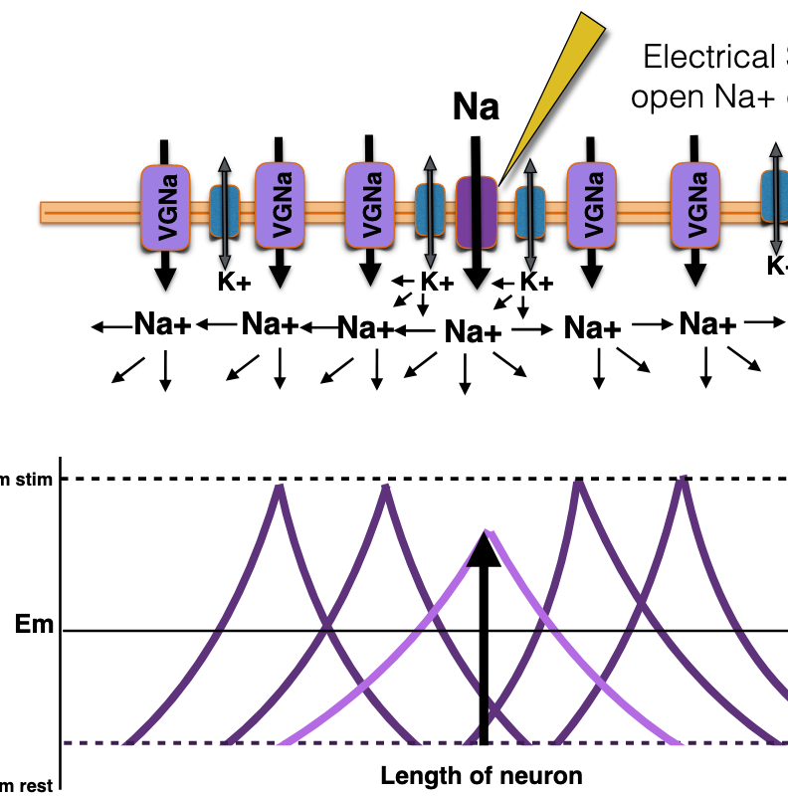
* Action potential lifecycle, in terms of membrane permeability
  + 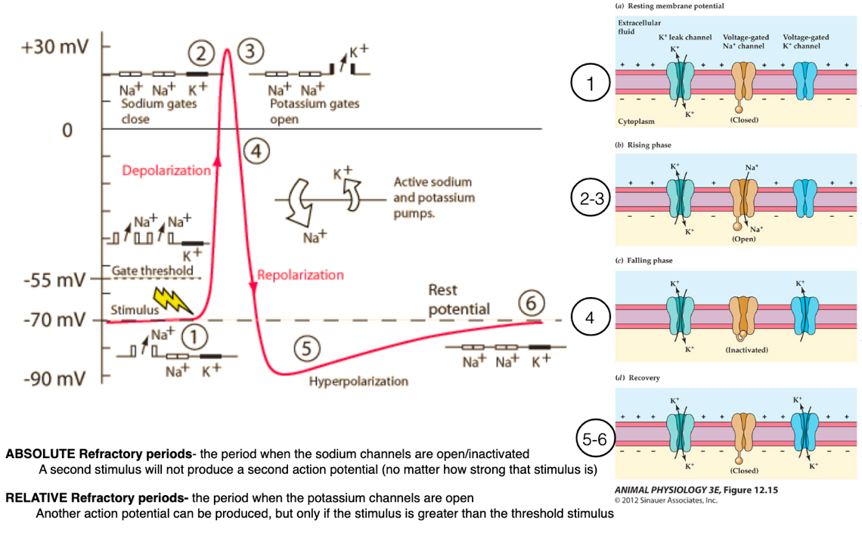
  + Rest, K+ leak channels only
  + Depolarization phase
  + Electrical stimulus, past gate threshold
  + Sodium voltage gated channels open, causing Na+ to go into cell
  + Depolarization peak
  + Sodium gates close
  + Repolarization
  + Potassium gates open, causing K+ to go out of cells
  + Hyperpolarization
  + Leaky potassium channels readjust until rest potential is reestablished
  + In summary, the generation of the action potential involves temporal opening/closing of several channels w/in the cell membrane.
* Refractory period
  + Absolute refractory period: when sodium channels are open/inactivated, a second stimulus will not produce a second action potential
  + Relative refractory period: when potassium channels are open, another action potential can be produced, but only if the stimulus is greater than the threshold stimulus
* Toxins
  + Alteration of these ion channels by administration of toxins can change action potential’s shape in a specific way, which can be a valuable tool for toxin classification and measurement of drug effects based on their mechanism of actions
  + If VGNaC is inhibited, no generation of action potential occurs
  + If VGNaK is inihibited, generation and propagation of action potential occurs, but the repolarization occurs slowly over time
* Ways animals address that the rate of action potential limits flow of information in the nervous system
  + Size, increase diameter of the axon to reduce resistance (invertebrates)
  + Insulation, add insulation to axonal membrane to reduce ability of current to leak out of axon and increase distance along axon (vertebrates)
    - If entire surface were insulated, there would be no place for the current to flow out (no VGNaC triggered), and action potential could not be generated
    - Myelinated axons speed the propagation of an action potential

## Class 10

How are neural systems organized to process and react to multiple stimuli? What are the variables involved in constructing nervous systems? How do synapses form the foundation of variable and precise neural control? How did neurons originate over evolutionary history? What is a brain in terms of structure and function across animals?

* Learning objectives
  + Cellular structures of neurons
  + Synapses
  + Neural circuits
  + Synaptic transmission (electrical, chemical, amount and type of chemicals)
  + Synaptic integration
  + Synaptic plasticity
    - Sensitization of gill-withdrawal reflex of Aplysia
    - Long term potentiation in mammalian hippocampus
* Information flow through axons
  + Dendrites -> cell body -> axon -> synapse
  + Synapses can be classified by type of cellular structures serving as presynaptic and postsynaptic components
* Neuronal circuit
  + Stimuli -> sensory neurons -> CNS interneurons -> motor neurons -> effectors
  + 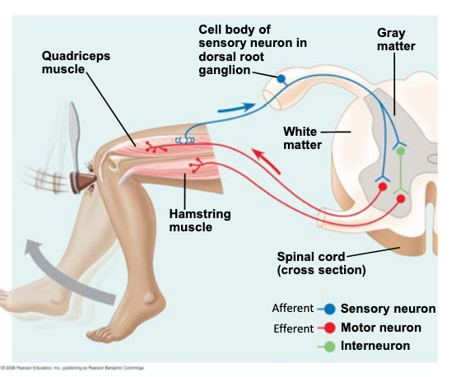
* Variables behind constructing nervous systems
  + Chemical vs electrical synapses
  + Synaptic integration
* Chemical vs electrical synapses
  + Chemical have graded response, have more degrees of freedoms (number of types of neurotransmitter, number and types of receptors)
  + Electrical are faster, bidirectional, passive, but signal degrades with distance
  + 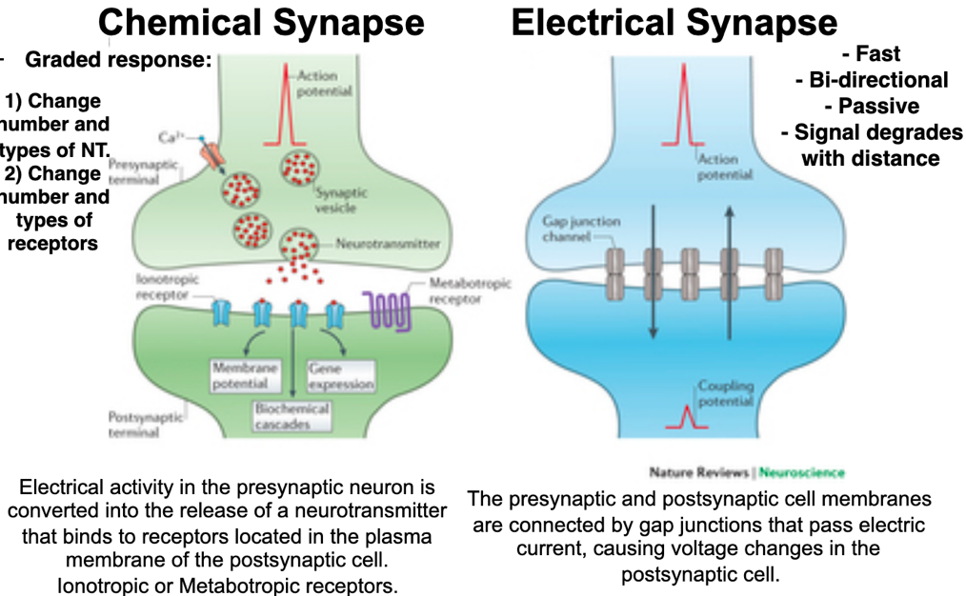
  + Excitatory and inhibitory chemical synapses can control whether a neuron generates an action potential
* Synaptic integration: “add up” inputs received before generation of an action potential
  + Temporal: summation of repeated and rapid stimulations of the same nerve
  + Spatial: summation of potentials generated from different physical locations of the cell body
* Combining these two techniques
  + Summation can integrate excitatory and inhibitory synapses, for further control
* Relationship between brain weight and body weight
  + Small animals tend to have relatively large brains, and large animals have relatively small brains
  + No correlation between absolute or relative brain size and intelligence
  + Animals differ in the number of brain neurons and cerebral cortex neurons
  + Elephants have a lot of brain neurons, humans have a lot of cerebral cortex neurons. Cognitive differences among species are quantitative
* Studying learning and memory through aplysia
  + Aplysia are a good model organism, since they have few neurons, cells are unusually large, and behaviors can be modified by learning
  + Kandel’s hypothesis: molecular pathways involved in learning and memory are ancient and conserved
  + In other words, the pathways discovered in aplysia is conserved across invertebrates and vertebrates, making them an even better model organism.
  + We can study an aplysia’s gill-withdrawal reflex to learn how we learn
  + The difference between short term and long term memory is the anatomical changes due to activations of gene expression
  + 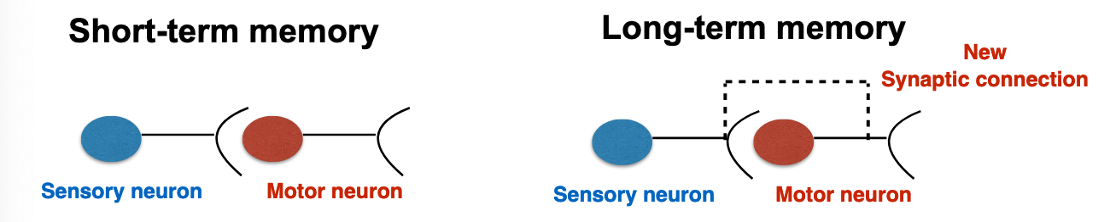
  + Repetitive stimuli are responsible for the genetic switch involved in long term memory and formation of new synaptic connections
* Studying learning and memory through mammalian hippocampus
  + Long term potential: synapses are strengthened related to learning and memory

## Class 11

How many modalities animals use to process sensory information? What is a transducer and how does it compare to engineered transducers? How is a stimulus turned into a neural signal? How are sensory systems studied by biologists? What aspects of sensory systems provide useful information for human products?

* Learning objectives
  + Difference between sense and sensory modalities
  + Stimulus, transducer, response
  + Encoding sensory stimuli
  + Tracking odor sources in lobsters and sharks
  + Electroreceptors
  + Magnetoreceptors
  + Biologically inspired sensorial machinery
* Definition and origin of a brain
  + Bacteria have voltage gated ion channels
  + Single celled animals w/o neurons use electrical signal sto respond to stimuli
  + Plants propagate signals using ion channels
  + In other words, life is electric!
  + From an evolutionary system, everyone agrees that nervous systems were at first diffuse and then evolved to be centralized
  + However, there is no consensus yet on exactly when this happened
  + We also know that some animals don’t have brains, though they do have the genes to build a nervous system. Did they lose their nervous systems because it’s too costly to maintain? Or did their animals that diverged from the same ancestor evolve their own nervous system?
  + Sea squirts simplify their brains during their lifetimes, suggesting that animals can lose their brains
* Perception: processing of sensory information by the brain
  + Animals have about 50 senses/sources of biological information
  + Animals have 5 sensory modalities/types of stimuli
    - Chemical
    - Temperature
    - Light
    - Electromagnetic fields
    - Mechanical
  + Although stimuli can be so different, the structures that respond to them are quite similar.
* Path of sensory information
  + Stimulus -> transducer -> response
  + Stimulus -> transduction/transmission by neuron -> response/interpretation by central nervous system
  + Stimulus: phenomenon in the environment that generates a response
  + Transduce: convert energy from one form to another
  + This is analogous for biological and non-biological system (microphone)
* Encoding stimuli into a neural signal
  + Depolarization of membranes
  + Second messenger systems
  + Changing rates of action potentials
  + Variable neurotransmitters and neural signaling pathways
  + Processing in specialized regions of the brain or just a generic body response
  + We know a lot of this stuff already!
  + 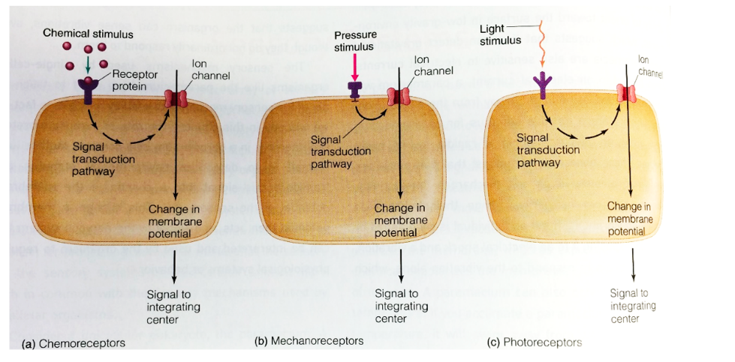
* Example of a mechanoreceptor
  + Insect bristle responds to displacements
  + Tail of lobster responds to stretching
  + Lobsters can encode the strength of signal in rate and patterning or action potentials
  + If no hairs bend, constant rate of neurotransmitter
  + If hairs bend in one direction, increase action potential rate
  + If hairs bend in the other direction, decrease action potential rate
  + 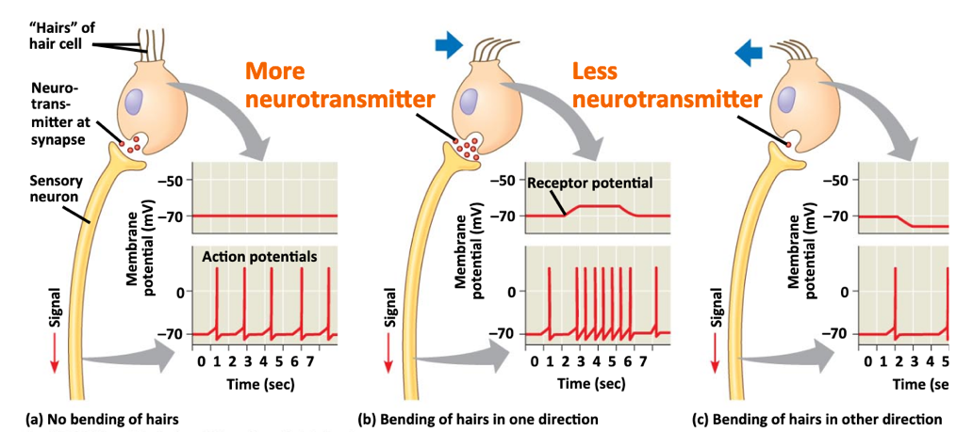
* Fishes have a lateral line
  + Hundreds of superficial neuromasts spread over head, trunk, tail fin
  + Neuromasts are made of hair cells and support cells encapsulated within a jellylike sheath called the cupula
* Electricity:
  + Electroreceptors are used to detect a slight change of electric field cause by nearby objects
  + Some fish can generate weak electricity or strong electricity, and some fish can sense electricity
  + Electric fish use modified skeletal muscles (electrolytes) to generate shocks. They are fired simultaneously, which causes them to be asymmetrically polarized, acting as serially connected batteries.
  + Sensing electricity allows for animals to detect prey!
  + Fish do this by using ampulles of Lorenzi, which are innervated gell-filled capsules distributed around the body
  + To avoid this, prey can stop moving and close gills
  + Platypi are not fish, but have electroreceptive organs in their bill.
  + This only works in water! Water is a good conductor, but air is a good insulator.
* Magnetism: many animals can sense and respond to Earth’s magnetic field as well
  + Many theories… magnetite? Cryptochrome?
  + In either case, may play a role in homing over short periods of time, or migration over longer periods of time
  + May be useful for birds and bees
* Chemicals:
  + Chemical sensing is ancient and found throughout tree of life.
  + Bacteria use it for chemical sensing and communication in bacteria, to count and make group-based decisions and communicating across species
  + Animals can use odor plumes to locate food, mates, home sites, etc.
  + Crustaceans sniff by flicking their olfactory antennules, and thus take discrete samples of ambient water and odors

## Class 12

What is the most primordial sensory system? How can we discern between taste and smell? What is an eye? What is the difference between reception and perception?

* Learning objectives
  + Chemical sensation
  + Temperature sensation
  + Photoreceptors
  + Image forming eye
    - Simple eye spot vs accessory structures, refraction, reflection, diffraction
    - Compound vs camera eye
  + Color vision, rods and cones
  + Specificity vs sensitivity
  + Reception vs perception
* Specificity: describes variety of receptors
* Sensitivity: describes number/density of cells
* Chemosensation
  + Consists of 5 modalities
  + Taste is same as smell, just in water instead of air
  + Can be highly specific
  + Can be highly sensitive
  + Low directionality
* Mammalian taste buds
  + Cluster of cells, each cell contains receptors for one taste quality.
* Transduction
  + Ionotropic: direct channel activation by stimulant, used for Na+, H+ (ion channels), capsaicin, wasabi, menthol
  + Metabotropic: GPCR based, used for sweet, umami, and bitters
  + 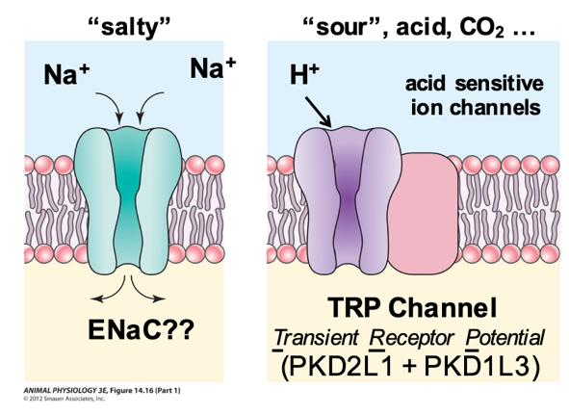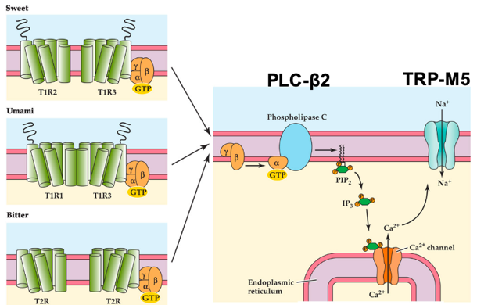
* Temperature sensation
  + Ionic receptors (TRP channels)
  + Receptors for hot and cold detection are the same as the receptors for capsaicin and menthol! The difference is in the processing in the brain
  + Processed by surface receptors and CNS (hypothalamus)
  + Low directionality (convection) except for some snakes, which process these signals as visual info.
* Visual sensation via eyes
  + Eyes are light-responsive sense organs that contain photoreceptors
  + Photoreceptive organs have evolved many distinct designs, but transduction is based on highly conserved proteins
  + Rhodopsin is a photoreceptor in vertebrates, signal is passed to transducing, a G protein
  + Chemical basis is conversion between cis and trans form
* Simplest eye
  + Shallow open pit lines w/ photoreceptors blackened by screening pigments
  + 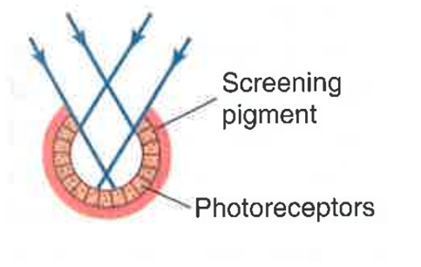
  + In flatworms
* Image forming eyes, properties
  + Pinhole: light enters at varying angles, create an image. Tradeoff: smaller hole has higher resolution, but reduces the amount of light
  + Refractive: change in direction of waves as they pass from one medium to another. Tradeoff: increase size of eye increases sensitivity but reduces resolution by reducing curvature
    - Emmetropia: no refractive errors
    - Myopia: nearsightedness, cannot see far items, image is focused in front of retina, requires diverging lens
    - Hyperopia: farsightedness, cannot see near items, image is focused behind retina, requires converging lens
  + Mirror: reflection changes direction of waves, can increase sensitivity to dim light by collecting more.
* Compound eye vs camera eye
  + Compound eye has lots of lenses to collect data, integrate them to form one image with high sensitivity to motion and have large view angle
  + Camera eye uses only one lens, has higher quality of vision
* Color vision via cones
  + Multiple opsins, different maximum absorption
  + 1 opsin per cell
  + Can tell intensity may be based on activation of multiple receptors and color based on combinatorial differences
  + Shrimp have a lot more opsins than humans, and scan across multiple channels (hyperspectral imaging)
  + Short wavelengths have spatial resolution
* Light vision via rods
  + Single rhodopsin
  + Insensitive to red
  + Can tell intensity only
  + High sensitivity, requires a single photon, but has low resolution
  + Bleach rapidly, so night vision only
* Transduction of light in vertebrates
  + Light strikes rhodopsin, G protein transducin is activated, activates cascade of events, closing Na+ channels. Membrane becomes hyperpolarized, so that it does not release glutamate to bipolar cell.

## Class 13

What is the physics beyond propagation of sounds? How are ears built in animals? How did the vertebrate ear evolve?

* Learning objectives
  + Waves, near field, far field, impedance
  + Diversity of paleontology of animal sounds
  + Directional hearing mechanism
  + Fish ears, inner ear and lateral line vs swim bladder
  + Mammalian ears, tympanic vs basolateral membrane, cochlea, middle ear bones
  + Vestibular systems
  + Cochlear implants
  + Insect ears, hair sensilla and antennae vs. cercal and tympanal organs
  + Origin of mammalian middle ear
* How did hearing evolve? Probably first to learn about environment, later to communicate, once they were able to make sounds
* Animals can detect many features of sound: frequency (pitch), duration, intensity, position of sound source, distance from sound source, relative speed of sound source)
* Wave: disturbance or variation that travels through a medium, which has particles that may experience particle vibration.
  + Particle vibration: local oscillations from the wave but do not travel with the wave itself
  + Pressure variation: particles of air oscillate back and forth
  + Near field only extends a few wavelengths from the source, represents one of two ways to perceive sound
  + Near field: particle movements
  + Far field: pressure waves
  + Acoustic impedance: ease w/ which a given environment builds backpressure and retards movement of area of pressure vibration
  + Near field is 5x greater than in air since the speed of sound is greater in water, so evolution required shift in sound reception strategy
* Insects
  + Hair sensilla
  + Antennae
  + Cercal organs
  + Tympanal organs
  + Insects have many potential auditory organs, and some detect far field while others do near field
* Sound localization
  + Using sound to detect where something is coming from
  + Interaural time difference: sense in one ear before the other
  + Interaural level difference: sense more intensity in one ear than the other
  + For good localization, need to maximize difference in distance or intensity
* Ears are an adaptation to different habitats
  + Terrestrial animals have outer ears w/ different shape and anatomy based on position in food chain
  + Forward often found on predators
  + Highly moveable ears often found don prey
  + Animals that fly or swim will not have outer ears to reduce drag and noise
* Hearing in fish
  + Near field: lateral line, inner ear
  + Far field: swimbladder coupled to inner ear
  + Lateral line has hair cells and is used in prey detection
  + Otoliths suspended in fluid and surrounded by ciliary bundles, so that for near field stimuli, sound vibrates the fish, and more dense otoliths lag behind, causing differential amplitude and phase, and send vibratory info to brain
  + 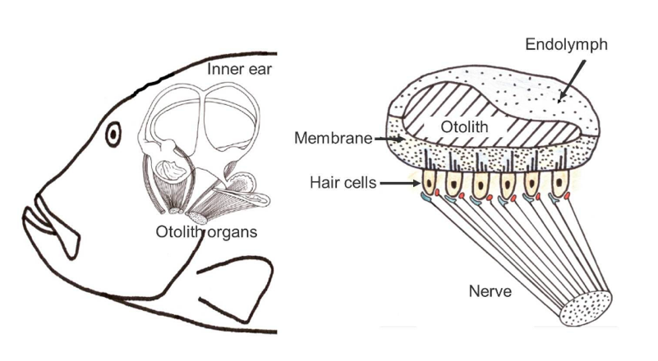
  + Many different strategies in fish
    - Hearing specialists
    - Hearing generalists
    - Pressure gradient acoustical energy
    - Particle motion acoustical energy
* Mammalian ears
  + Pinna and auditory canal filter sound frequencies
  + Tympanic membranes respond to acoustic pressure waves
  + Middle ear bones transduce pressure waves into vibrations that can be sensed by mechanoreceptors
  + Semicircular canals transduce movement and position into neural signals
  + Cochlea transduce frequency into neural signals
    - Vibration transmitted from stapes to fluid in vestibular and tympanic ducts
    - Vibrates basilar membrane
    - Vibrates hair cells
    - Hair cells depolarize
    - Round window dissipates vibrations to they’re not reflected back into cochlea
  + 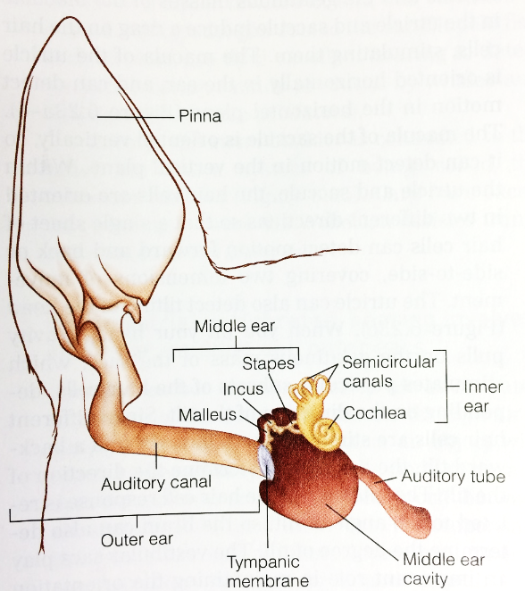
  + Basilar membrane varies in stiffness and width, vibrates at different frequencies along its length, thereby encoding frequencies w/ different stimulation
* Cochlear implants
  + Difficult to get implant into spiral of inner ear
  + Solution is to use material with flexible tip and stiff base
* Vestibular system
  + Detects postural equilibrium
  + Semicircular canal responds to rotational movements (angular acceleration)
  + Vestibule responds to changes in position of head with respect to gravity (linear acceleration)
* Origin of mammalian ear
  + Probably from articulation for upper and lower jaws
* Sound can be used for echolocation

## Class 14

Cancelled!

## Class 15 part 1

What are some of the physical and physiological reasons for the evolutionary diversity of circulatory systems?

* Learning objectives
  + What is the role of the heart?
  + How animals without a heart can survive?
  + Open vs closed circulatory system
* What is the role of the heart? Why do animals need a heart?
  + Diffusion is only effective at very small scales
  + For larger scale molecules, we need bulk flow, or fluid movement cause by *pressure* gradients
  + Bulk flow delivers key nutrients and remove wastes
* If bulk flow is important and the heart is necessary for the heart to generate a pressure gradient, do all animals need a heart?
  + No, some animals have a large surface area and a lot of muscular movements. These tend to be all animals living in water.
* For animals that have hearts, they can be divided into open and closed hearts
  + **Open hearts:** Invertebrates, for example, have pumping tubes and open hearts. At the periphery, blood flows into interstitial space into organs. Some membrane slowly brings heart back to the heart. What are advantages/disadvantages of such a system?
    - 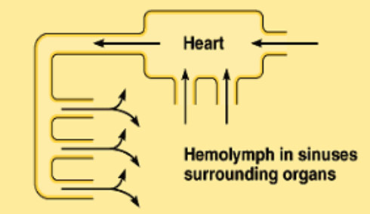
    - Disadvantage: limited size, diffusion works only on small scales
    - Disadvantage: lack of fine control over blood flow, not as precise as closed systems
    - Advantage is that the pressure and resistance are low, so the rate of blood flow can be high despite small pressure.
  + **Closed hearts:** The most simple is in the worm, which has multiple pseudo-hearts
    - 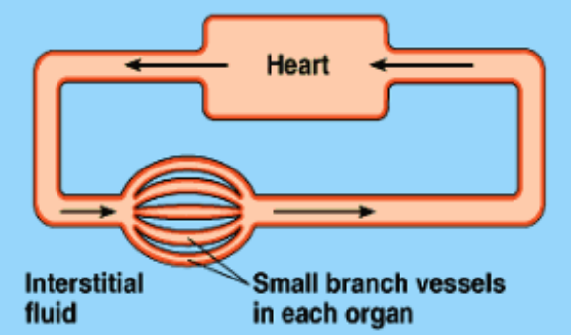
    - Advantage: finer spatial and temporal control over blood flow pattern. For example, vasodilation and vasoconstriction.
    - Disadvantage: For blood to circulate at high rates, blood needs to circulate at high rates, and large pressure differences are required.

## Class 15 part 2

How do processes of small-scale flow connect to large scale flow in the operation and function of circulatory systems?

* Learning objectives
  + Hagen-Poiseuille equation
  + Principle of continuity
  + Circuits in series vs parallel
  + One heart vs two hearts
* We can model blood using circuits from physics
  + Ohm’s law: relates potential difference (V) to current (I) and resistance (R)
 $$V=IR$$

   - In circuits, potential difference is similar to pressure difference, and current is sort of like blood flow
  + Darcy’s law: relates pressure difference (Delta P) to blood flow (Q) and resistance (R)
 $$ΔP=QR$$

 + Poiseuille’s law: substitute equation for resistance into Darcy’s law, relates rate of flow (Q) to fourth power of radius (R).
    - 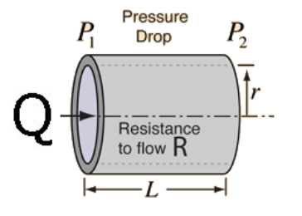
 $$Q=ΔP/R$$

 $$Q =\frac{πPr^{4} }{8ηl}$$

  - Eta is viscosity
    - l is length of tube
* How do you build a circulatory system that moves blood in the most efficient way?
  + Thin tubes or thick tubes?
    - Thick tubes have less resistance, increase flow
    - However, in order to maximize diffusion, need small tubes
    - We can address this by using big tubes for delivery and small tubes for diffusion
    - 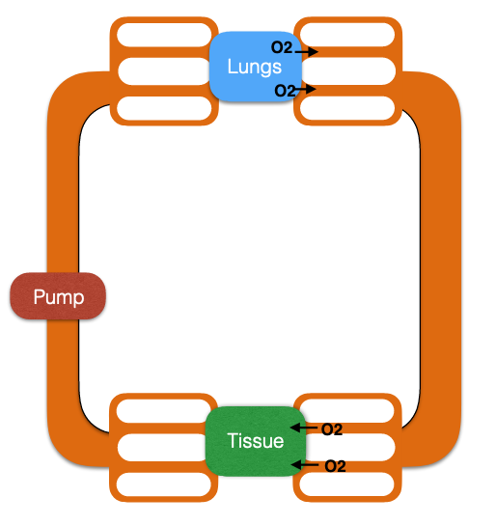
    - However, this will increase velocity a lot, due to the principle of continuity (A1 v1 = A2 v2). If the area of the tube decreases, the speed of the fluid must increase. For effective diffusion, we need low velocity.
    - We can address this by using a lot of capillaries, so the total cross-sectional area increases, so that the velocity actually decreases.
    - 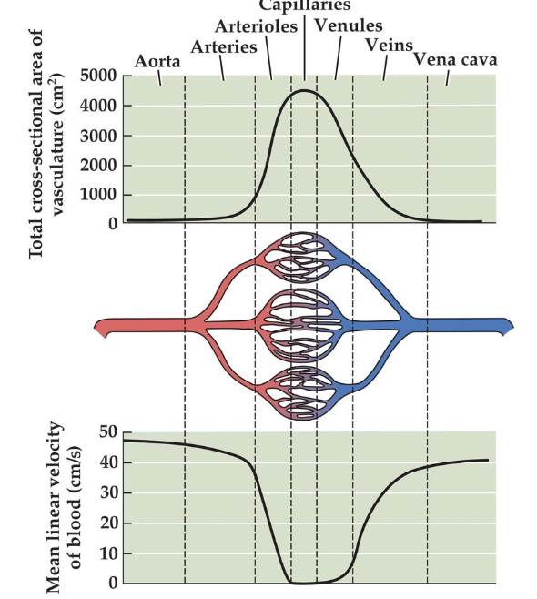
  + Arrange tissues in series or parallel
    - 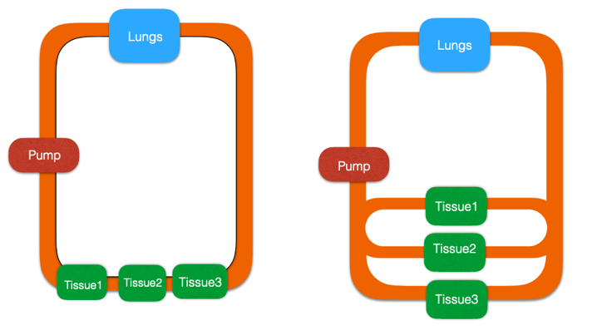
    - In parallel, there is less resistance overall, and we can vary relative flow to tissues by adjusting resistance (vasodilation and vasoconstriction).
    - This also has a connection to physics!
  + How many pumps to use?
    - One pump/single circulation: blood flows through heart once, i.e. fish with 2 chambered heart
      * Pressure drops through the circuit
    - Two pumps/double circulations: blood flows through heart twice, i.e. humans with 4 chambered heart
      * Advantage: we can have one pump with high pressure to deliver blood to peripheral tissues, and another with low pressure to deliver blood to pulmonary circulation.
    - Three chambered heart: save energy by shutting down pulmonary circulation
      * Blood moves from right atrium to left ventricle, and back into systemic circulation
    - 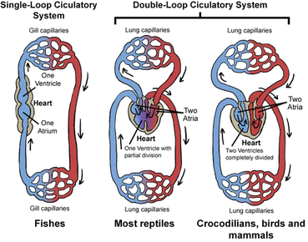

## Class 16 Part 1

How do processes of small-scale flow connect to large scale flow in order to guarantee both delivery and exchange?

* Learning objectives
  + Primary mechanisms of capillary exchange
    - Blood hydrostatic pressure
    - Blood colloidal osmotic pressure
  + How venous blood returns to the heart
* Osmosis: passive transport of water across a membrane toward equilibrium of its concentration
  + Osmotic pressure is determined by colloidal concentration, where colloids are microscopically dispersed particles
  + Water moves from region if low osmotic pressure (few colloids) to high osmotic pressure (lots of colloids)
  + Osmotic pressure is also known as oncotic pressure
* Hydrostatic pressure: pressure exerted by fluid, by the heart and blood on the vessels
* We can break tubes down into having four different types of pressure:
  + Blood colloidal pressure
  + Blood hydrostatic pressure
  + Interstitial fluid colloidal pressure
  + Interstitial fluid hydrostatic pressure
  + However, interstitial colloidal and hydrostatic pressures are low, so we can focus on blood pressures instead
  + As blood moves along the capillary:
    - Hydrostatic pressure decreases, as blood moves away from heart
    - Colloidal pressure stays the same, because proteins remain in vessel
    - Based on the differences in pressure, what this means is that at the arterial end, blood flows out of the capillary, and in the venuous end, blood flows into the capillary
  + Inevitably, more fluid will exit at arterial end than enters at venous end, and the excess fluid will be picked up capillaries of the lymphatic system. This fluid is filtered at a lymph node before being returned to a vein.
  + Pressure throughout the system:
    - Systolic pressure: maximal aortic pressure, following ejection from left ventricle
    - Diastolic pressure: minimal aortic pressure, just before ventricle blood ejected into aorta
* As the blood goes through the circuit, loses pressure, almost to 0 when it gets back… so how does venous blood return to the heart at low pressure?
  + Muscle contraction
  + Valves: close to avoid backflow

## Class 16 Part 2

What is the effect of gravity on the cardiovascular system and how did living systems evolve and adapt to terrestrial gravity?

* Learning objectives
  + What is the effect of gravity on the cardiovascular system
    - Blood pressure
    - Posture changes
  + How did living systems evolve and adapt to terrestrial gravity?
    - Adaptation to different environments
* Pressure is dependent on height
  + Pressure exerted by a static fluid depends on only depth (h), density (rho), and gravity (g). Pressure does not depend on the total mass or volume of the liquid.
 $$P=ρgh$$

 + Using this equation, we can imagine that we would have greater pressure at the foot compared to the head. This pressure equalizes when we lie down.
* Adaptations in tall animals, i.e. giraffes
  + Increase pressure by increasing strength of heart’s muscles.
  + Problem: blood pools at legs
    - Solution: thick skin that counteracts pressure to the feet
  + Problem: different gravitational effects for posture changes
    - Solution: Precise control and regulation of blood pressure and flow
      * Valves in the main veins that automatically close (preventing backflow)
      * Complex maze of small blood vessels at the base of the brain to collect excess blood, rete mirabile
      * Quick changes in vasodilation and vasoconstriction at feet and head
    - Tree vs ground snakes also have posture effects
      * For ground snakes, head is level with heart, if head is tilted more than 45 degrees, blood flow to head drops to 0
      * Tree climbing snakes tend to have higher blood pressure and maintain flow to head
* What adaptations could a Brachiosaurus have had to counteract pressure effects?
  + Hearts?
    - Big hearts? Many hearts in neck? Never lifted its head?
  + What if it was in a lake vs on ground?
* Environmental considerations
  + Gravitational effects only on land and not water, since blood and walter have similar density. Hydrostatic pressure increases with depth, cancels out increases in pressure due to gravity
  + When humans in space with no gravity, blood goes to chest and head, but then the body adjusts.

## Class 17 Part 1

Why is oxygen important? How much oxygen is available in the air vs water?

* Learning objectives
  + Why is oxygen important?
    - Call for oxygen
    - Composition of atmospheric air
    - Partial pressure
  + How much oxygen is in the air vs water?
    - Solubility of gases
      * Boyle’s
      * Henry’s
    - Respiratory surfaces
    - Cost of breathing air
* Atmospheric air
  + Nitrogen, oxygen, noble gases and other gases
  + 21% oxygen, 78% nitrogen, 1% CO2 and other gases
  + At high altitude, there is less oxygen, in the sense that the pressure of the air is lower
  + Partial pressure: partial pressure for one gas is independent of other gases present, and sum up to total pressure
    - P total = P N2 + P O2 + P CO2 = 760 mm Hg
    - Knowing the percent of air allows us to calculate partial pressure. For example, PO2 = P total * 21%.
  + Boyle’s law: pressure of gas is inversely related to volume
    - P1 V1 = P2 V2
    - When diving, water is much denser than air, increasing the pressure on gas spaces and decreasing the volume
    - Whales have an adaptation, since they are not using their lungs, they compress them, and this reduces the squeezing effect and also helps with buoyancy.
  + Henry’s law: Amount of dissolved gas in liquid is proportional to partial pressure in the gas phase
    - 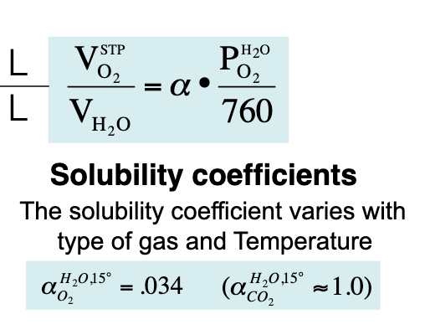
    - When diving, solubility of gases increases, so nitrogen dissolves into blood. When going up too rapidly, solubility decreases rapidly as well, forming bubbles. (The bends)
    - O2 is hard to dissolve in water (small, nonpolar), CO2 is easy (also small and nonpolar, because binds to water to become hydrated)
* Basic components of gas transfer system in animals
  + 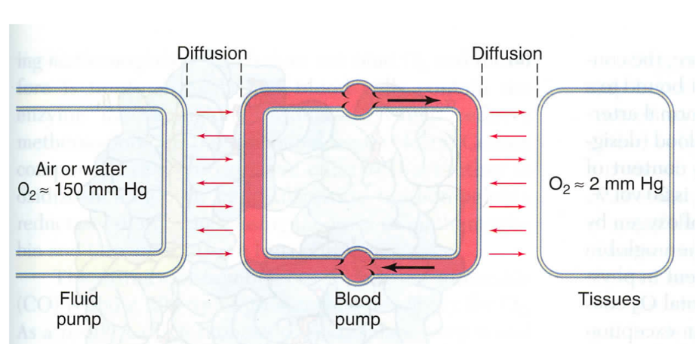
* Challenges of animals moving to land
  + Need thin membranes to allow oxygen to diffuse
  + If a membrane is thin, will also be thin enough to allow water to diffuse and evaporate
  + Solution: respiratory surfaces always need to be wet
* Advantages of breathing air
  + Costs less to ventilate
  + Water has low solubility, need to move a lot more water to get same amount of oxygen. Furthermore, water is a lot more viscous and has greater density.

## Class 17 Part 2

Is oxygen available sufficient to meet our metabolic need?

* Learning objectives
  + Altitude
  + Humidity
  + Temperature
  + Salinity
  + Environments in equilibrium with air
* Problem: How much O2 do we need to meet our metabolic demand, and how can we get it to diffuse in water?
  + Need a gradient
  + Assume sea level, dry air
  + Based on calculations, there is enough oxygen, but not nearly enough.
  + Furthermore, life is not ideal!
* Pressure
  + Pressure drops with humidity
  + Birds have bigger lungs, bigger wings, etc. to minimize energy cost
* Humidity
  + If more water in the air, proportion of oxygen is less
* Temperature
  + Oxygen solubility decreases at a higher temperature
* Salinity
  + For animals living in water, oxygen solubility decreases at increased salt concentration (salting out effect)
  + Evaporation concentrates salinity, precipitation dilutes it
  + Biggest effect when freshwater river meets salt water sea.
* Water is not always at equilibrium with air.
  + During the day, oxygen increases because of photosynthetic organisms, and at night, less oxygen

## Class 18 Part 1

How do partial pressure and solubility work together to determine oxygen and carbon dioxide concentrations in blood and hemolymph? What are the key mechanisms by which respiratory pigments facilitate oxygen uptake and release?

* Learning objectives
  + Efficiency as matching perfusion and ventilation
  + Role of respiratory pigments to increase O2 solubility in blood
  + Significance of O2 dissociation curve and its application to understand different physiological conditions
    - Bohr effect
    - Exercise
    - Fetal Hb
    - Acclimation to high altitudes
* Mammals have lungs
  + Trachea branches into bronchi and bronchioles, which divide into alveolar ducts, which give rise to alveolar sacs that contain the alveoli, where gas exchange takes place
  + Ventilation and perfusion
    - Ventilation (V): rate at which air is moved across a respiratory surface, or supply from lungs
    - Perfusion (Q): rate at which blood flows in circulation, or demand from tissues
  + Goal of the lung is to match perfusion and ventilation
    - An analogy of ventilation and perfusion is that ventilation fills a bathtub with water while perfusion removes the water, and under steady state conditions, the water leaving the drain is equal to the water coming into the spigot
    - Levels of O2 and CO2 are related inversely through shared ventilation and blood flow, because O2 is taken inhaled and CO2 is exhaled
* Problem: low solubility of oxygen in water, need to increase solubility to keep up with demand
  + It’s more expensive to increase circulation, since it takes work.
  + A better solution is to use respiratory pigments to increase solubility of O2 in the blood, i.e. hemoglobin, hemocyanin, hemerythrin, chlorocuorin.
  + Looking at distribution of pigments in animal kingdom, no straightforward pattern of evolution, meaning that they evolved independently multiple times.
  + Many organisms have hemoglobin, which has 4 protein subunits and a heme group with iron associated with it
  + Some marine invertebrates have hemerythrin, which does not have heme. It uses copper instead, and floats in the hemolymph instead of being stored in blood cell.
* Oxygen dissociation curve
  + O2 + Hb <-> HbO2
  + Fully saturated when all binding sites are full
  + Sigmoidal if cooperative, hyperbolic if no cooperative
  + Cooperativity affects deoxygenation as much as it affects oxygenation
  + Hemoglobin and myoglobin
  + Two methods of presenting oxygen equilibrium curve
    - Partial pressure of oxygen in blood on x axis
    - Percent of heme groups oxygenated on y axis
    - Or, mL of O2 per 100 mL of blood (vol %) on y axis
    - P50: partial pressure of O2 at which a pigment is 50% saturated
    - From left to right, exercise, tissues, and lungs, because towards the left, oxygen will be unloaded, and to the right, the oxygen will be loaded
* Physiological conditions
  + Bohr effect: increase in [H+] decreases Hb O2 affinity, shift curve to right to favor O2 unloading over loading
  + Exercise: increase in O2 demand, so also shift curve to right
  + Fetal hemoglobin: higher affinity for O2, shift curve to left to favor O2 loading over unloading

## Class 18 Part 2

What are the key mechanisms by which respiratory pigments facilitate CO2 uptake and release? How does O2 affinity vary within and across species to accommodate varying environments? How does O2 affinity and other tricks allow diving mammals to succeed in a marine environment?

* Learning objectives
  + CO2 transport in blood
  + Buffering role carbonic acid bicarbonate system
  + Case study of Andean hummingbirds and ice fish
  + Diving mammals
* CO2 transport in blood
  + CO2 + H2O <-carbonic anhydrase-> H2CO3 <-> HCO3- + H+
  + 5-10% dissolved in plasma
  + 20% bound to carbamino compounds (hemoglobin)
  + 70-75% as bicarbonate ion
  + In vertebrates, carbonic acid anhydrase is found in RBC or endothelial cells, never free in blood. CO2 enters and leaves as CO2 rather than bicarbonate ion because it can diffuse more rapidly
* CO2 transport in blood from tissue to RBC
  + CO2 enters RBC
  + CO2 converted to H2CO3 by carbonic anhydrase
  + H2CO3 dissociates into HCO3- and H+
  + HCO3- goes out via chloride shift
  + Meanwhile, H+ shifts hemoglobin curve (Bohr effect), unloading oxygen
* CO2 transport in blood from RBC to lungs
  + Basically the reverse of the process above since the reactions are reversible, except Aldene shift instead of chloride shift
* Carbonic acid bicarbonate system is a good buffer system!
  + CO2 + H2O <-> HCO3- + H+
  + Proteins are also good, since they can act as acids or bases
  + When blood pH is too low, body reacts by exhaling more CO2, shifting equation to the left, so that less H+ ions are free
  + When blood pH is too high, body reacts with more shallow breathing, shifting equation to the right, so more H+ ions are free
* Icefish: lost expression of oxygen carrying proteins
* Andean hummingbirds: live at high altitudes
  + Potential mechanisms:
    - Change total quantity of hemoglobin
    - Change ratio of hemoglobin isoforms to increase affinity
    - Change in allosteric regulation of O2 affinity
* Marine mammals: lots of adaptations
  + Storage: O2 in hemoglobin, O2 in myoglobin, O2 in lungs
  + Greater oxygen carrying capacity of Hb
  + Greater total volume of blood (more in diving)
  + Greater degree to which blood is fully loaded with O2
  + Skeletal muscles contain more myoglobin
  + Regional vasoconstriction to limit blood flow
  + Changing heart rate

## Class 19 Part 1

What are the key parameters for respiratory systems? What are the strategies to incorporate efficiency into the mechanisms of respiratory systems?

* Learning objectives
  + Strategies to increase diffusion by changing the parameters of Fick’s law
  + Evaginated vs invaginated respiratory surfaces
* Fick’s law review – Delta J is the flux of oxygen
 $$ΔJ_{O2}=-\left(DA\right)\frac{ΔC}{Δx}$$

 + Decrease Delta x:
    - Flatworms have thin outer surface (small delta x), increasing flux
  + Increase A:
    - Jellyfish increase surface area (large A), increasing flux
    - Flatworms and worms increase surface area by adding evaginations and invaginations. These organisms must live in wet/moist environments to avoid drying out due to increased surface area.
  + Increase Delta C:
    - Cold, fresh, moving H2O have more O2
    - Gambusia live in warm, still water, so to get oxygen, they need to breathe at the top of the water level.
    - Lungless salamanders have no lungs, so need to be close to cold, fresh, moving water to breather.
    - These organisms also have other adaptations to survive, such as low metabolic rate.
* What about organisms that are larger and have a high metabolic rate?
  + 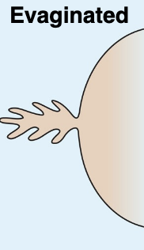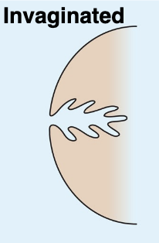
  + Evaginated respiratory surface (gills)
    - Gills are evagination of skin (coming out)
    - Highly convoluted to increase surface area
    - Two layers of cells (epithelial, endothelial) to decrease delta x
  + Invaginated respiratory surface (lungs)
    - Also highly convoluted
    - Also two layers of cells
  + Differences
    - Lungs solve problem of dehydration, respiratory surfaces must always be wet
  + Similarities
    - Both need ventilation, not just diffusion

## Class 19 Part 2

What are the key parameters for respiratory systems? What are the strategies to incorporate efficiency into mechanisms of respiratory systems?

* Learning objectives
  + It is not only about diffusion, also need ventilation
  + Unidirectional ventilation
  + Bidirectional ventilation
  + Surface tension
* Need for ventilation
  + Around a respiratory surface there is an unstirred layer of water that is not well mixed, and this reduces the diffusion of O2
  + Ventilation maintains a high rate of O2 by moving the unstirred layer around the respiratory surface
* Unidirectional ventilation (living in water)
  + Moving gills through still water
    - One way to increase ventilation is to simply move gills through the water
    - This is expensive, because of the large density of water
    - Gills are fragile and thin tissues, and are vulnerable
    - Fish solve this by protecting them with a cover (operculum)
    - 
  + Ram ventilation
    - As fish swims, water goes through mouth, passes through gills
    - Need to be fast swimmers, such as sharks and tuna, and must not stop moving
    - This is a passive movement, but has added cost of drag due to having mouth open
    - 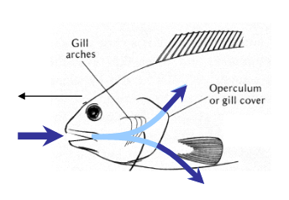
  + Buccal pumping
    - Open and close mouth constantly, changes volume to create pressure difference that moves water in the mouth and out the operculum
  + Moving legs
    - In crustaceans, gills are on the legs, so moving the legs moves water across the gills
* Bidirectional ventilation (living on land)
  + Since moving air (less dense) is a lot cheaper than moving water (denser), strategies are very different
    - Air moves through mouth twice, (in and out)
    - Protects from water evaporation
    - However, decreases PO2 in alveoli because of the residual volume (not all of the air is replaced each breath)
    - This means that with each breath, some fresh air is mixed with stale air, so the partial pressure of oxygen is not the same as the environment. Furthermore, the partial pressure of oxygen is already a bit less because it is wet
  + Inhalation and exhalation in mammals
    - Inhalation: diaphragm and intercostal muscles contract, decrease pressure, and based on Boyle’s law, allows air to rush into lungs, increasing lung volume
    - Exhalation: elastic tissue of lungs recoil, intercostal muscles relax, return chest wall to original position, increasing pressure within thoracic cavity, pushing air out; this is a passive movement
    - 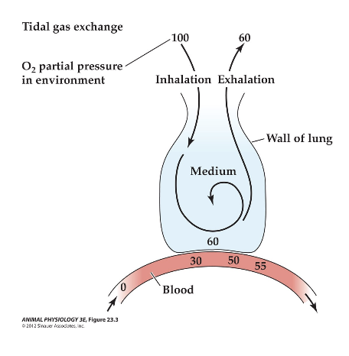
  + Breathing In amphibians
    - No ribs or diaphragm, so movement of floor of the mouth is what changes the pressure to allow air in/out
    - Inhalation: lower the floor of the mouth, air goes into the body from environment, the nostril closes, and air is forced into lungs by contracting the floor of the mouth
    - Exhalation: lower the floor of the mouth, air goes into body from lung, nostril open, floor of mouth moved up to push air out of nostrils
    - Frogs can also breathe through the skin when completely submerged under water for long periods of time
    - Frogs can also breathe through the buccopharyngeal membrane, a lining along the mouth, though this can only occur while the frog is not submerged in water, since it requires opening the mouth
    - 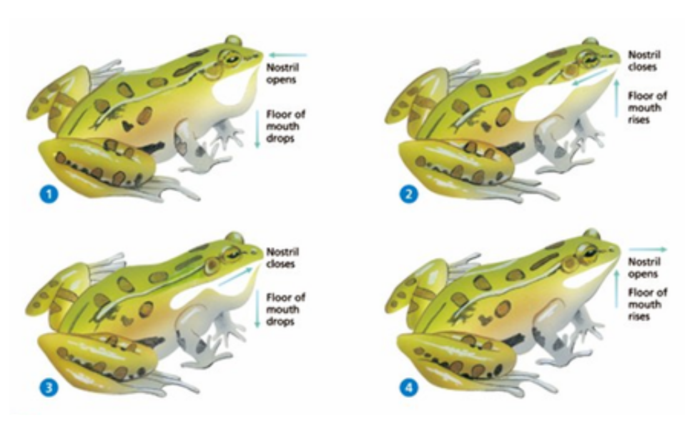
  + Similarities
    - Moving air is cheap, but inflating the lung is very expensive (surface tension)
      * Pressure required to expand a sphere depends on the resistance and on the curvature, i.e. a small radius has more curvature and more resistance.
      * Surface tension is due to water trying to get away from air, water tends to reduce surface to air
      * This means that we can’t get rid of all the air in the lungs, otherwise our lungs would collapse
      * Respiratory surfaces are wet, and stretching a film of water is expensive due to the hydrophobic effect
    - Surfactants reduce surface tension, increase compliance
* Why do fish suffocate when out of the water?
  + On the one hand, it’s easier to ventilate, there’s more oxygen
  + On the other hand, because of surface tension at the gills when air and water interact, the gills will want to stick together
  + Some fish, such as the walking catfish, use a modified swim bladder as a lung, gulping air and absorbing oxygen from there
* Birds
  + Have unidirectional air flow, expand and collapse anterior and posterior air sacs
  + A complete cycle involves two inspirations and two expirations
  + Since this is unidirectional, there is no mixing of O2 with CO2 in the same space, there is no work to expand the alveoli (rigid tubes), and there is no residual volume
  + This means that birds have a higher volumetric rate for the same breathing frequency (more efficient)
  + 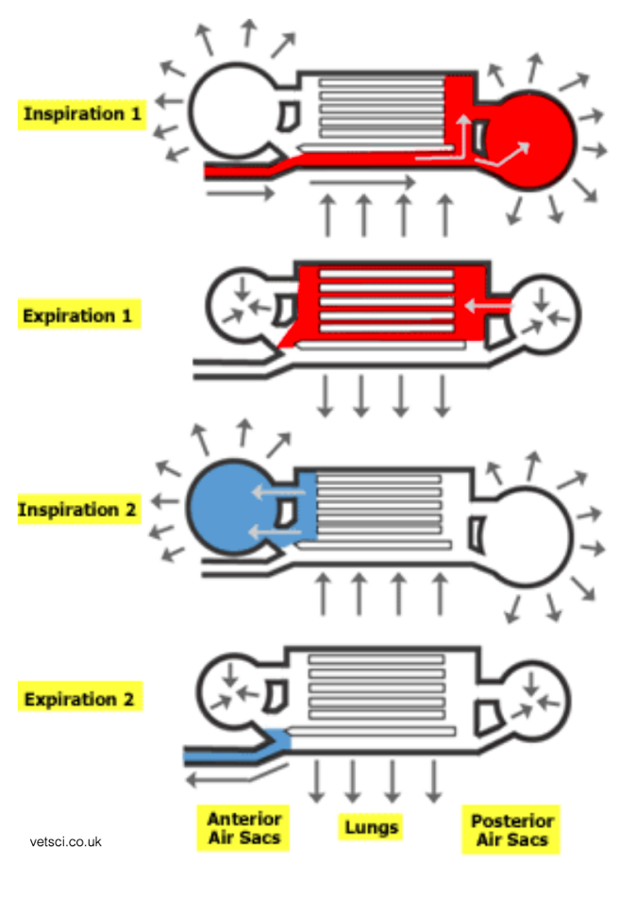
* Insects
  + Impermeable to water
  + Tracheal system in direct contact with tissues
  + Spiracles open and close, regulated by O2, CO2, and relative humidity
  + Hemolymph transports nutrients, chemicals, heat, and not gas
  + 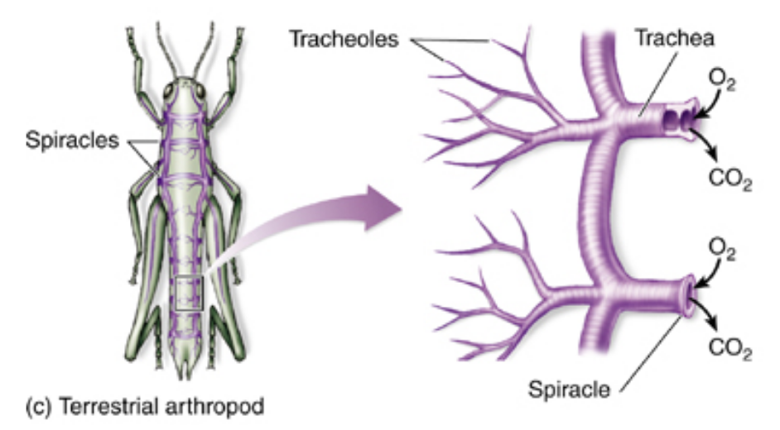

## Class 20

What are the key different strategies for gas exchange to provide efficiency in bulk flow respiratory systems? What are other applications of these strategies in different physiological systems?

* Learning objectives
  + Counter current exchange as a core component of the efficiency of bulk flow, to maximize exchange by maximizing concentration gradient
  + Other applications of counter current exchange mechanism in different physiological systems
    - Nose in mammals (humans vs camels)
    - Regional heterothermy
    - Temporal bypass in insects
* Counter current exchange
  + Two parallel pipes separated by a permeable membrane
  + Dissolved materials will flow from high concentration to low concentration solution
  + Degrees of freedom:
    - Flow in the same direction vs opposite direction
    - Long vs short pipes
    - Close vs distant pipes
  + By having the two parallel pipes flow in opposite directions, the exchange of the dissolved solute is maximized because the gradient is maintained across the entire length of the surface exchange
    - In cocurrent exchange, the two pipes equalize after a certain distance
    - In countercurrent exchange, even the more saturated pipe is losing its concentration to the less saturated pipe, it is simultaneously flowing towards an even less saturated region of the less saturated pipe, so the gradient is maintained.
* Examples
  + Fish
    - Unidirectional flow, but with countercurrent exchange
    - Water flows through spaces between secondary lamellae from buccal side to opercular side, while blood flows through the secondary lamellae in the opposite direction
  + Birds
    - Also unidirectional, but cross current exchange (almost countercurrent, but not quite)
    - Afferent blood vessel breaks in many vessels that cross the path followed by the medium
    - Better than cocurrent, but not quite as efficient as counter-current
* Countercurrent exchange can also be used in other ways, not just gas exchange
  + Regional homeothermy, strategically align arteries vs veins
    - Moose minimizes heat loss at the tip of its legs (extremities), which may be in snow. Since these organisms are homeotherms, losing heat would need to be replaced, which is costly.
    - Whales keep muscle of the tongue vascularized without losing heat
    - Tunas and sharks too
  + Breathing in mammals
    - Incoming air is drier and colder, but we need it to be wet and hot
    - Use the nasal mucosa
    - Incoming air is warmed and humidified, and cools the nose
    - Outgoing air is cooled and loses water, wetting the nose
    - Camels also use counter current exchange, in addition to high convulated structures to increase area of exchange and a sponge
  + Insects
    - Warming of flight muscles increases power output
    - Shivering is used as a preflight warm up
    - As a consequence of high muscle temperatures generated during flight, some insects need to thermoregulate to maintain thoracic temperature
    - Temporal bypass of countercurrent exchanger
    - During inhalation, venous blood is pulled into abdomen
    - During exhalation, arterial blood is pushed towards muscles
    - Bypass separates two flows in time, reduces transfer of heat between aorta and venous channel

## Class 21 Part 1

How does a single cell control water permeability across the membrane? How do animals maintain water and NaCl balanced in the body?

* Learning objectives
  + Osmolarity
  + Cell/volume regulation
  + Osmo-regulators
  + Osmo-conformers
* Lots of pathways for water to go in and out
  + Absorption through epithelium, i.e. food and drink
  + Metabolism
  + Insensible water loss
  + Excretion, i.e. urine and feces
  + 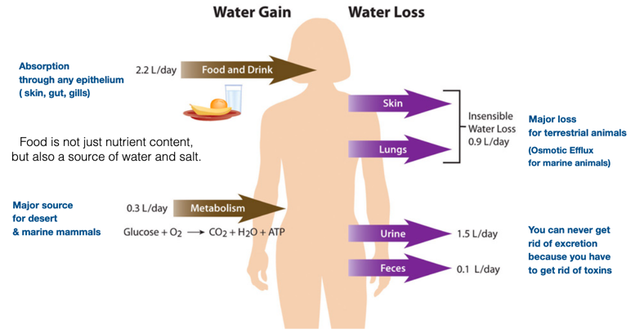
* Composition of body fluid constitutes the context in which the cells, organelles, and molecules function. Mammals are 60% water, and part of the other stuff are organic ions. In fact, the ionic composition of the body fluid affects
  + 3D molecular conformation
  + Electrical gradient
  + Nerve impulse transmission
  + Muscle excitation
  + Cell volume
  + Hydrostatic pressure
* Body fluids
  + Intracellular
  + Interstitial
  + Blood plasma
  + Interstitial tends to be similar to blood plasma by osmosis
  + Intracellular has osmotic pressure as other fluids
  + However, intracellular composition is different, due to ion pumps
  + Note that osmotic pressure is also not oncotic pressure
* Fundamental problem of cell volume regulation
  + In saltwater, water moves out of cell, vs in fresh water, water moves into cell
  + Plants and yeast solve this problem by creating cell wall
  + Animals move NaCl using a pump, and water follows. This comes at the cost of energy (ATP).
  + 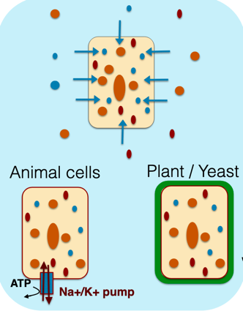
* Osmoregulation
  + Isosmotic line applies to conformers
  + Regulator does not follow isosmotic line
  + 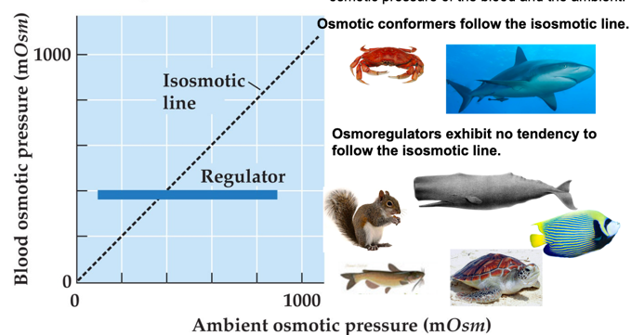

## Class 21 Part 2

What are strategies organisms use to maintain water and NaCl balance in different environments

* Learning objectives
  + Hyperregulators
  + Hyporegulators
* Osmoregulators can be divided into two groups, hyperregulators and hyporegulators
  + Hyperregulators have blood hypertonic to environment, i.e. fish
    - Pump NaCl out, water follows
    - Problem, need to reabsorb NaCl
      * Low intracellular Na+ concentration generated by Na+/K+ pump creates driving force for Na+ to move into cell across apical membrane Na+ channel
      * This system is present in gills of fish, skin of amphibians, renal epithelium of mammals
      * 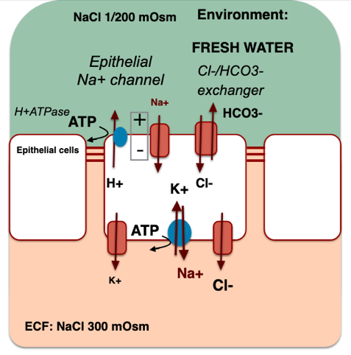
    - Sweating
      * Pump NaCl, water follows
      * Active reabsorption of NaCl by cystic fiborisis transmembrane conductance regulator (CFTR), though it requires metabolic energy
  + Hyporegulator have blood hypotonic to environment
    - Examples
      * Bony fish and marine reptiles
      * Marine birds w/ nasal salt glands
      * Iguanas in Galapagos w/ nasal salt glands
      * Crocodiles w/ lingual salt glands (can only tolerate saltwater for a short amount of time)
      * Sea turtles w/ eye salt glands
      * Sharks w/ anal salt glands
    - Drink seawater, taking in water and NaCl
    - Pump NaCl back out
    - Don’t have sodium pumps, use chloride cells
    - Low Na+ concentration in the cell acts as driving force for Na+ into cell across basolateral membrane through Na+ K 2Cl- cotransporter. Cl- moves out of cell through channel in apical membrane, creating electrical gradient across epithelium, which facilitates passive movement of Na+ through leaky junctions between cells
    - Mammals do not have Cl- cells so they can’t drink seawater
    - 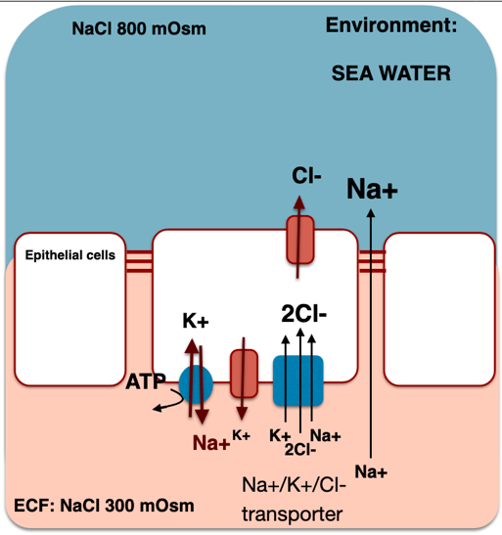
  + Smoltification allows organisms to alternate between fresh and salt water in their lifecycle

## Class 22 Part 1

What are key strategies for removing waste and what are the major wastes that need to be removed? What does a kidney “do” and how?

* Learning objectives
  + Difference between ammonia, urea, uric acid
  + Excrete only waste or filtrate everything and then bring back only the good things
  + Bowman’s capsule and the importance of blood pressure
  + Proximal and distal tubule
* Why excretion is important
  + Maintain proper solute concentrations
  + Maintain proper body volume (water content)
  + Remove foreign substances
  + Remove metabolic end products
    - Waste products include H2O, CO2, heat, and NH3
    - NH3 is toxic and needs to be removed
    - Has to do with the citric acid cycle
* Ammonia, urea, uric acid
  + Amino groups arise from proteins and nucleic acids, metabolized
  + Ammonia is cheap to make but is toxic and requires a lot of water to be secreted. I.e. aquatic animals, most bony fishes
  + Urea requires 2 ATP to remove one carbon monoxide and two amino groups but is mildly toxic and doesn’t require a lot of water to be secreted. I.e. mammals, most amphibians, sharks, some bony fishes
  + Uric acid is expensive to produce but is not toxic and requires almost no water to be secreted. I.e. reptiles and birds, insects, land snails
  + There is a tradeoff between water needed to excrete and energy needed to produce
* There are many other wastes to remove as well…
  + Should an organism attempt to identify all wastes and remove them?
  + How can an organism get around this problem of identifying all wastes?
* Excrete only known toxins and wastes
  + For example, malpighian tubules in insects
  + No filtration and primary urine is formed by secretion of solutes and water.
  + Waste consists of both urine and feces mixed together, and potassium urate is secreted into tubules.
  + Water is reabsorbed into the body, and waste fluid goes into the gut
* Filtration system, requires a physical filter and bulk flow
  + Why? Organism doesn’t need to know everything to secrete, allows organisms to move into new environments
  + Flagellar beating is one way to get flow, and this is generally present in primitive and small animals such as worms and rotifiers
  + Ultra-filtration is another way to get flow. Primary urine formed by hydrostatic pressure filtration of vascular fluid into coelomic space, drawn into duct where the secondary urine is formulated, and this is generally present in mollusks and all vertebrates
    - Organisms only know what the good stuff is, not the bad stuff
* Kidneys
  + Bowman’s capsule, which has podocytes (specialized epithelial cells) as physical filters
  + Podocyte organized like a net around glomerular blood vessels, let everything below 10 kDa move out into filtrate, which is primary urine.
  + Filtrate is almost identical to blood plasma, except it lacks high molecular weight solutes such as plasma proteins
  + Nephrons have pressure generated by heart, blood pressure must exceed osmotic pressure of blood proteins (colloidal osmotic pressure)
  + 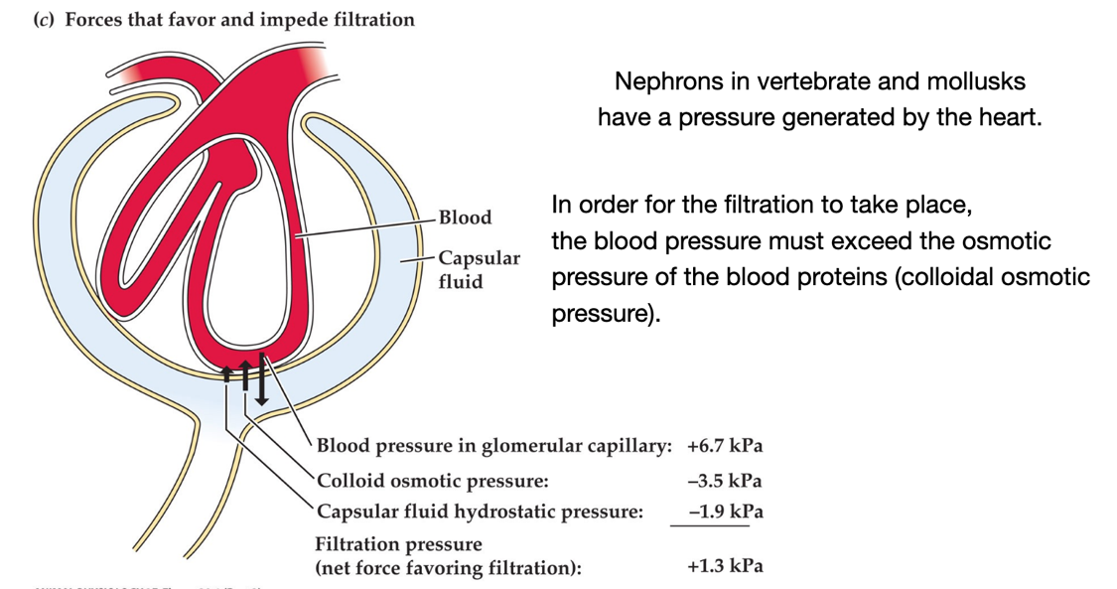
  + If blood pressure is too high or low, will increase or decrease urine production
  + Proximal tubule reabsorbs good stuff, such as glucose, salt, amino acids, HCO3-
  + Distal tubule secretes bad stuff, such as H+, NH4+, uric acid in reptiles, sulfates
  + 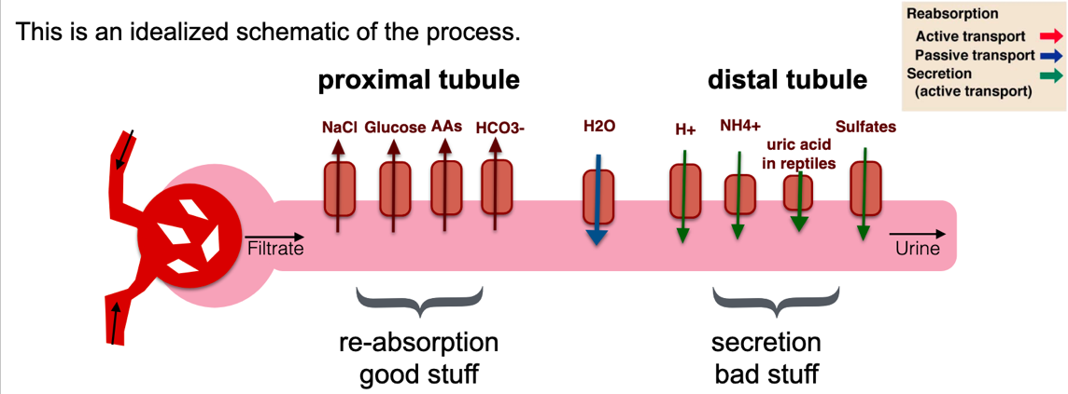

## Class 22 Part 2

How do mammals and birds differ in the production of urine compared to other vertebrates?

* Learning objectives
  + Bowman’s capsule
  + Proximal and distal tubule
  + Loop of Henle, countercurrent multiplier strategy
  + Non-excretion functions of kidney
* Birds and mammals are only vertebrates that can produce urine more concentrated than blood, by using Henle’s loop between proximal and distal tubule, which takes advantage of countercurrent multiplier
  + Descending part of loop is permeable to water, but not ions
  + Ascending limb of loop is not permeable to water, but is permeable to ions
  + Event #1:
    - 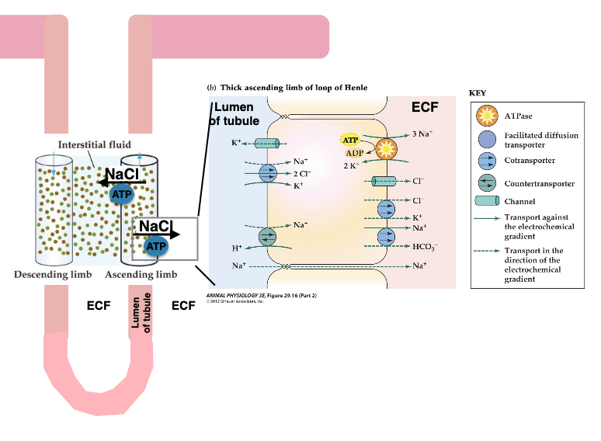
    - NaCl is reabsorbed on ascending loop, not exactly a chloride cell, but similar mechanism
      * The mechanism is on apical side transporting NaCl into the body
    - This increases the osmolarity of the interstitial fluid as the tubule descends into the inner medulla, pulling out water from the filtrate
    - Because the overall osmolarity of the filtrate decreased when NaCl was pumped out in the loop of Henle, urine becomes more concentrated and more water is saved
  + Event #2:
  + 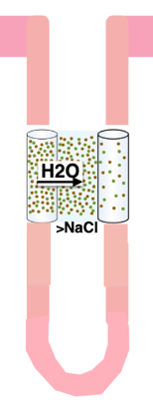
  + Different location of transporters for solutes and water generates an asymmetric reabsorption
  + Active transport is only in ascending part
  + Descending and ascending part of loop are close to each other in opposite direction
  + Osmotic pressure and concentration of ions in the ascending limb fluid are lowered from their original levels, whereas the osmotic pressure and concentrations of ions in the interstitial and descending limb fluids are raised.
  + Single effect: Side-to-side difference between limbs that are next to each other:
  + Countercurrent multiplier system: end to end difference is sum of single effects along the whole limb, or the length multiplied by the concentration difference.
* Event #3
  + Collecting duct allows for fine-tuned control of water balance through aquaporin channels, directed by hormones
* Countercurrent multiplier vs exchange
  + Multiplier is active, uses metabolic energy to induce flux of commodities into or out of fluid systems (vs passive exchange)
  + Multiplier is active, creates differentials from end to end along axis of flow (vs constant gradient)
* Other functions of kidneys
  + Excretion of nitrogenous wastes, water soluble toxins, by ultrafiltration
  + Ion balance, by distal and proximal tubules
  + Osmotic balance, by aquaporin channels in collecting duct
  + pH balance, by retaining or excreting H+ or HCO3
  + Hormone production

## Class 23

What are the differences and similarities between neuronal and endocrine systems? How do feedback mechanisms form the foundation of homeostasis?

* Learning objectives
* Differences between nervous and endocrine system
  + Speed of action: hormones are slower, while nerve impulses are very fast
  + Size of target and precision of control: hormones affect all sensitive cells they reach and require a receptor, while nervous system affects only a single target cell
  + Length of impact: hormones have long effect, nervous system is short and requires repetition for lasting effects
  + Distance of action: hormones use bloodstream for global distribution, while neuronal transmission is local
  + Structural design: endocrine systems do not have a structurally linked design, while nervous system does
* Similarities between nervous and endocrine system
  + Chemically, both are the same, but use same transmitters in different ways
* Nervous system structure
  + 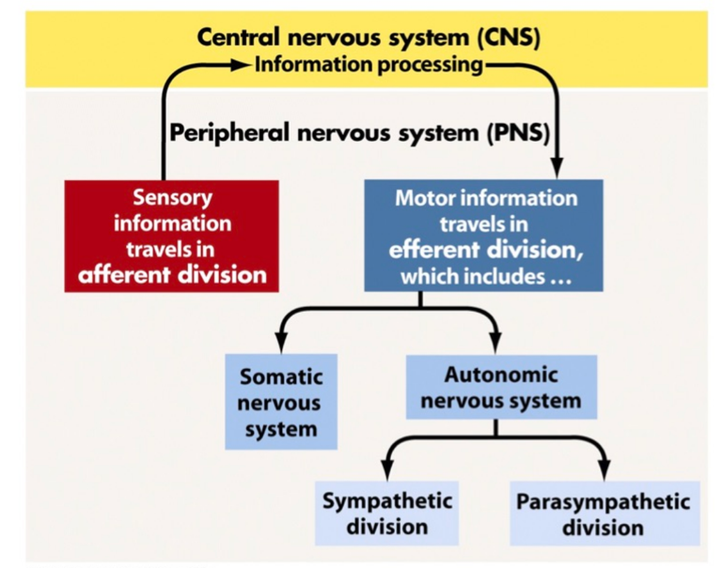
  + Sympathetic and parasympathetic have opposite effects. There are control mechanisms to ensure that both are not active at the same time.
  + Sympathetic helps mediate emergencies through release of epinephrine and norepinephrine (aka adrenaline and noradrenaline)
  + Parasympathetic controls body’s response while at rest, using Acetylcholine (Ach) on two types of receptors, muscarinic and nicotinic cholinergic receptors.
* Hypothalamus in the brain plays a role as the main neuroendocrine interface in vertebrates. It coordinates a central role in control of behavior.
  + Almond sized brain structure present in all vertebrates. It is interesting how it evolved
  + Senses ions and blood temperatures
  + Major role in controlling most basic life-sustaining drives
* Hypothalamus is connected to pituitary gland
  + Neurosecretory neurons in hypothalamus secrete hormones that strictly control secretion of hormones from anterior pituitary. This is through hypothalamic hypophyseal portal veins
  + Anterior and posterior pituitary secrete other hormones that collectively influence all cells and affect virtually all physiological processes.
* Control systems
  + Negative feedback
  + Positive feedback
  + 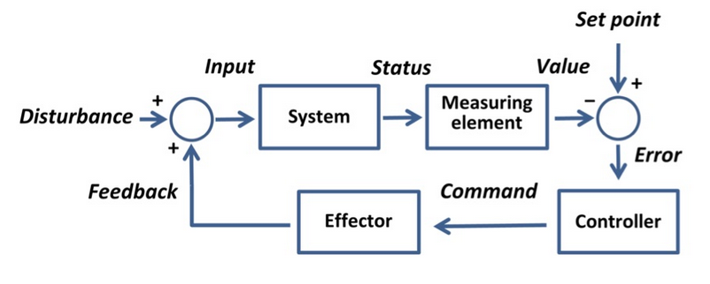

## Class 24

How is stress managed by the endocrine and nervous system? How is blood pressure controlled and regulated by the endocrine system and nervous system?

* Learning objectives
  + Hypothalamo-Pituitary-Adrenocorticol (HPA) axis
  + Sympathetic nervous system
  + Short term mechanisms
  + Long term mechanisms
* Stress: a stress response is a physiological response to ensure survival in an acute crisis. However, if the stressor persists for long period, physiological responses that are adaptive in the short term become damaging in the long term.
  + General stress response: regardless of the stressor, the stress response is always the same
  + This makes sense, whether you predator or prey, you will need to move!
  + One of the hallmarks of stress response is the rapid mobilization of energy from storage sites and the inhibition of further storage.
  + During an emergency, your body halts long term (to ensure there is a long term), expensive building projects, inhibits immune system, perception of pain, while increasing cognitive and sensory skills
* Hypothalamo-Pituitary-Adrenocorticol (HPA) axis
  + 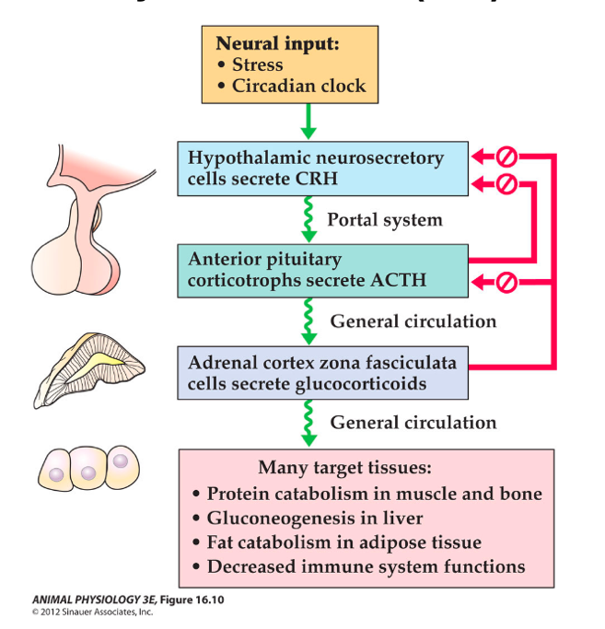
  + Principal endocrine component of the stress response involves activation of the HPA axis, which involves a neuroendocrine cascade culminating in the synthesis and secretion of glucocorticoids
  + Glucocorticoids modulate stress response at a molecular level by modulating various levels of gene expression
  + In chronically stressed animal, sensitivity to glucocorticoids decreases, so the negative feedback loop is not as effective
* Sympathetic nervous system
  + 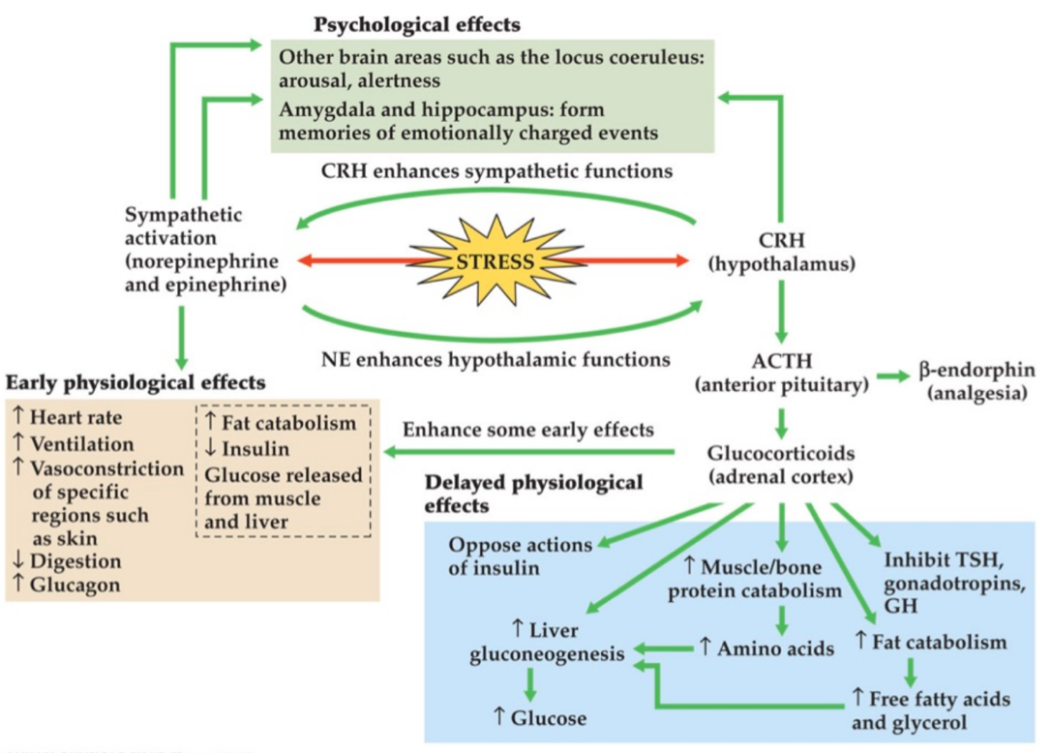
  + Epinephrine and norepinephrine also play a role, have earlier effects than glucocorticoids
* While all stress response is the same, the speed and magnitude and manifestation of stress might vary depending on the stressor
* Stress and memory
  + Short term stressors of mild to moderate severity enhance cognition, while major or prolonged stressors are disruptive
  + Inverse U relationship
  + 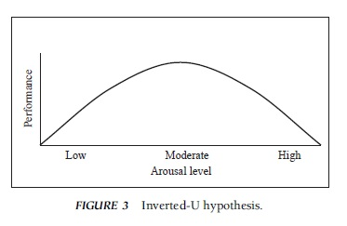
  + Timing also matters, if stress experienced during learning experience, glucocorticoids facilitate memory. If stress experience before learning, glucocorticoids impair memory
* Short term stress can ensure survival, but how about long term stress?
* Effect on long term stress
  + Continuously constricted blood vessels lead to chronic high blood pressure
  + Action of glucocorticoids to catabolize proteins and fatty acids to form glycogen eventually leads to muscle wasting and bone thinning. In other words, if you constantly stop long-term building projects, nothing is ever repaired
  + Immune suppression leads to increased susceptibility to disease and infections
  + HPA axis activation leads to increased susceptibility to decreased reproductive function
  + Damage to hippocampus neurons reduces dendritic formation, death of neurons, shrinkage of hippocampus (loss of ability to form memories, especially of emotional events)
* Regulation of blood pressure
  + Baroreceptors can tell blood pressure
    - Carotid sinus and aortic arch baroreceptors (mechanoreceptors)
    - Continuously have electrical output about blood pressure
    - Rate of firing increases with increased blood pressure, decrease in blood pressure decreases rate of firing
    - 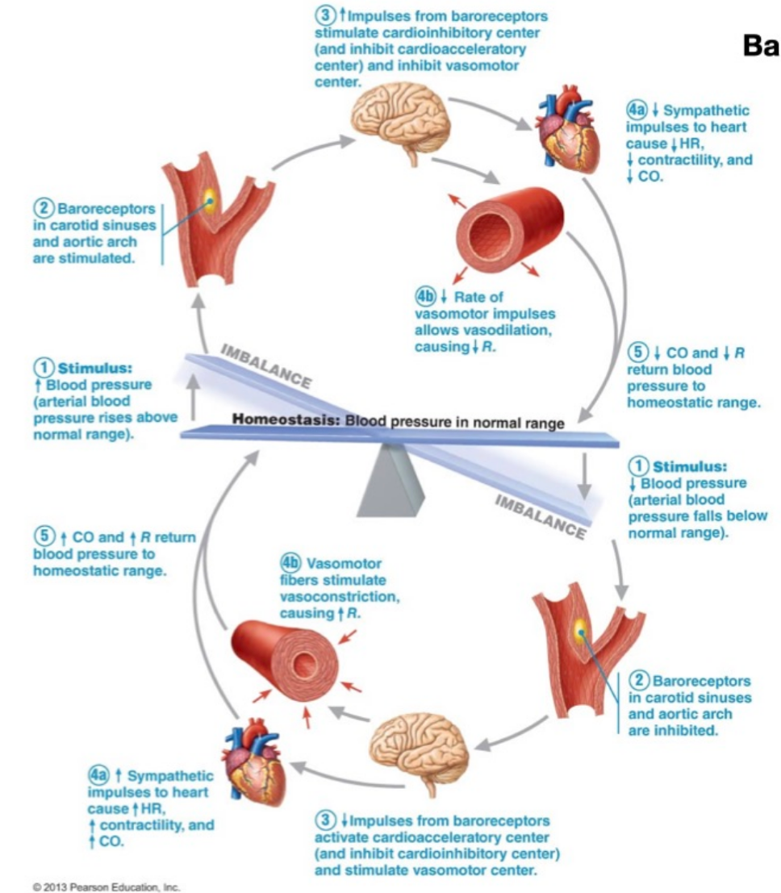
    - Near baroreceptors are also chemoreceptors that can tell oxygen, carbon dioxide, pH, etc.
  + Integration center
    - Afferent – medulla
    - Efferent – autonomic system
  + Short term mechanisms
    - Regulate blood vessel diameter, heart rate, contractility
  + Long term mechanisms
    - Regulate blood volume (urine output and thirst)
    - Renin-angiotensin-aldosterone system
    - Macula densa cells can detect salt
    - Make sure you understand the steps!
* 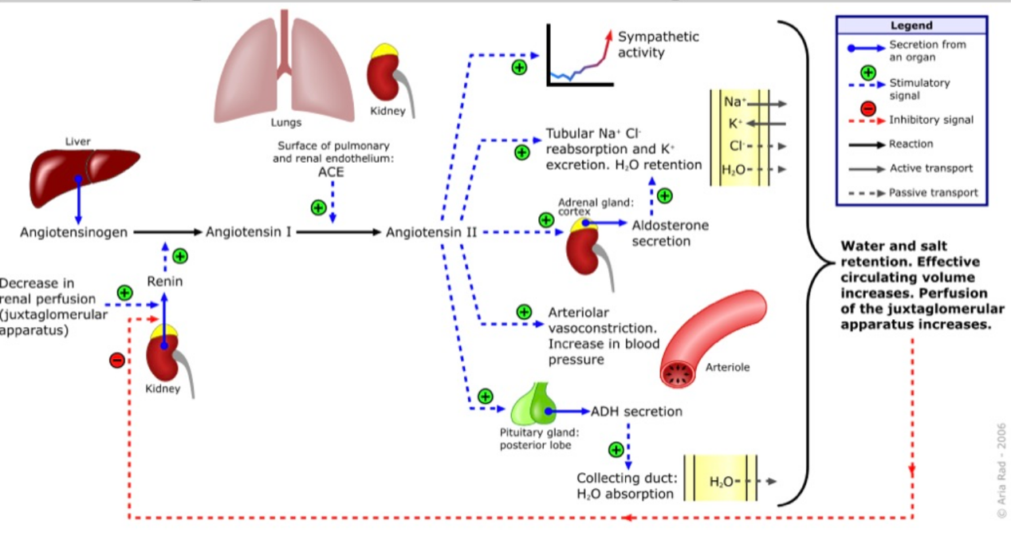
  + When blood volume is low, juxtaglomerular cells in kidney secrete renin into circulation
  + Converts Angiotensin from liver to Angiotensin I.
  + Angiotensin converting enzyme (ACE) converts Angiotensin I to Angiotensin II.
  + Angiotensin II is a peptide that causes blood vessels to constrict
  + Also stimulates aldosterone from adrenal cortex, increasing reabsorption of sodium and water in blood, increases volume of fluid in body and blood pressure
  + ADH (vasopressin) created by hypothalamus and secreted by posterior pituitary blood, also has vasoconstrictive effects, but mainly increases reabsorption of water in the kidney, causes thirst and craving for salt
  + This means there are so many targets for blood pressure drugs.

## Class 25

How does the body control and regulate energy balance? What is obesity and what are the possible therapeutic applications? How is blood glucose level regulated in health and diseases?

* Learning objectives
  + Leptin
  + Discovery of leptin
  + Hypothalamic regulation of food intake and energy metabolism
  + Gut-brain cross talk
  + Pathophysiology of obesity
  + Insulin/glucagon synthesis, release, and actions
  + White, brown, beige adipose tissue
* Obesity is a uniquely human problem
  + All energy producing and storing reactions are highly conserved pathways in many if not all organisms
  + There are short- and long-term control systems that regulate energy intake and expenditure/storage
  + In truly feral animals, true obesity is a rare occurrence, though some periodic imbalances of body weight can be adaptive, i.e. for hibernators, migration, pregnancy
  + Obesity is a uniquely human problem
* Evolution of obesity
  + Controversial
  + Thrifty gene hypothesis: biologically adapted to cope with worst case scenario of food storage and potential starvation
  + Maladaptive hypothesis: by-product of positive selection on some other traits
  + Drifty gene hypothesis: genes that predispose us to obesity are neutral and have been drifting over evolutionary time
* Obesity has many different facets
  + Genes, diet, environment/lifestyle, all interact with each other
  + Gene-environment interaction: one ethnic group in different environments develop obesity at different rates, “our genes permit us to become obese, our environment determines if we become obese”
* Hypothalamus: integrator of peripheral signals on nutritional state
  + Lesions in lateral hypothalamus -> anorexia
  + Lesions in ventromedial hypothalamus -> obesity
  + Hypothalamus is highly conserved from fish to humans
  + Since the brain is sort of separate from the body, scientists realized that body weight is controlled by a factor that circulates in the blood
* Leptin and discovery
  + Two strains of mice w/ two different genetic mutations lead to obesity.
  + To tell if there was a circulatory element, they performed parabiotic experiment
  + Parabiotic experiment: two mice sutured together to form a shared circulatory system.
  + Based on these experiments, proposed that ob/ob mice lacked a circulating satiety factor, and db/db mice overproduced the factor but could not respond to it (so they will never feel full).
  + Ob + normal mice, ob decreased weight of ob mouse bc satiety factor transferred from normal to ob. This implies existence of factor.
  + Db + normal mice, normal decreased weight of normal mouse suggests that the db component does not circulate, and is overexpressed
  + Ob + db mice, ob lost weight because they got the satiety factor
  + Cloned the gene, purified the gene product (leptin)
  + Humans with leptin deficiency before and after treatment shows decrease in weight.
  + This doesn’t cure obesity, since obesity is often due to leptin resistance
  + Leptin is produced by ob gene.
  + Leptin is secreted by fat cells into bloodstream
  + Leptin acts on hypothalamus/brain to regulate food intake and energy expenditure, suppressing appetite until weight is lost
  + Therefore, food intake and metabolism is physiologically regulated, fat is an endocrine organ, and obesity is a problem for biology
* Leptin and insulin
  + This is how leptin and insulin interact. (not much further discussion)
  + 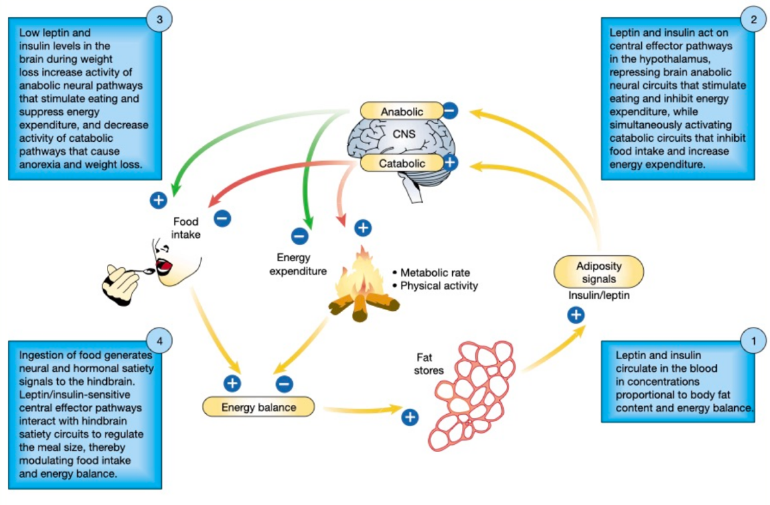
* Gut-brain cross-talk also controls metabolism
  + Stretch receptors in stomach activate sensory afferent pathways in vagus nerve and inhibit food uptake
  + Ghrelin released by stomach, esp. during fasting, stimulates appetite
  + Peptide YY, cholecystokinin (CKK), and insulin and gastrointestinal hormones that are released by ingestion of food and suppress further feeding
  + Vagal neurons convert nutrient dependent changes in gut hormonal milieu into electrochemical info
  + Only discussed insulin
* Insulin
  + Regulates blood glucose
  + Synthesized by beta cells of pancreas, alpha cells secrete glucagon, d cells secrete something else, and f cells are unclear
  + Pancreas consists of endocrine (blood) and exocrine glands (duct tube, such as sweat and salivary glands)
  + 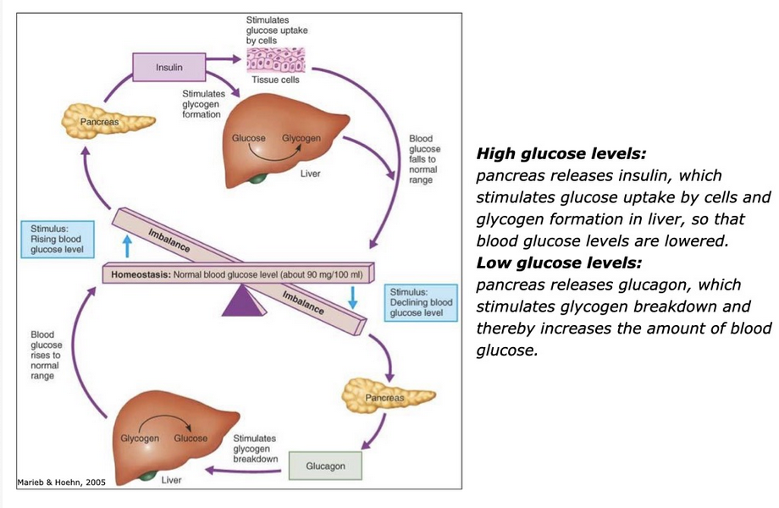
  + Glucose metabolism -> rise in ATP:ADP ratio -> closure of ATP-sensitive K+ channels -> plasma membrane depolarization -> activation of voltage gated Ca2+ channels -> Ca2+ mediated stimulation of exocytosis
  + First phase is due to secretion of preformed insulin (first 10 min)
  + Second phase reflects newly synthesized insulin stimulated by other glucose-derived second messengers
* Glucose/insulin/glucagon relationship
  + Increase in glucose and insulin peak at same time, glucagon goes down
* Diabetes types 1 vs 2
  + Type 1: absence of insulin, secondary to autoimmune destruction of pancreatic islet cells
  + Type 2: reduced response of target tissues to insulin (insulin resistance)
  + Exposure of tissues to elevated dietary nutrients and toxic metabolic by-products is main driver of insulin resistance
  + Obesity is most common factor for initiating development of type 2 diabetes
  + At first, body overcompensates by producing higher levels of insulin after meals
* Food as a hormone
  + Specific direct and indirect actions to activate receptors and signaling pathways
  + Certain amino acids can activate signaling pathways involved in food uptake and energy relocation
  + Obese people found to have more branched-chain AA’s, and this in addition to high fat diet may contribute to insulin resistance
* Types of fat
  + White, brown, beige (hybrid) fats
  + White stores energy in triglycerides
  + Brown helps maintain thermal homeostasis

## Class 26

What are the levels of analysis for reproductive systems? How did reproductive systems evolve and differentiate across the kingdom? How do endocrine disruptors impact animal reproductive systems and what are the major challenges in studying/assessing the imapacts?

* Learning objectives
  + Sexual vs asexual reproduction
  + Internal vs external fertilization
  + Induced vs spontaneous ovulation
  + Sex determination
  + What are endocrine disruptors, what do they do, and what are their effects?
* Asexual vs sexual
  + Asexual is primary form for single-celled organisms
    - Rapid population growth
    - Good for stable environments
  + Sexual requires fusion of gametes
    - Increased genetic diversity
    - Combine beneficial mutations from parents to speed adaptation to local environments
    - Avoid passing along all harmful mutations and instead pick up healthy mutations
* Semelparous vs iteroparous
  + Semelparous: reproduce only a single period in their lives
  + Iteroparous: multiple reproductive cycles over lifetime
  + Tradeoff between fecundity, growth, survivorship
  + Small Australian marsupial mice are only semelparous mammals, have suicidal reproduction, where mice have a frenzied mating season where they use all their resources for reproduction, and then their immune system crashes and their bodies fall apart and then they die. This is also partly due to the fact that the sperm competes within a female’s reproductive system, rather than the animals competing for the females.
* Induced vs spontaneous ovulation.
  + Induced: endogenous processes in female, regulated by endorphin system, depends on copulation, which initiates sequence of endocrine events that release egg from ovaries. This has advantage of being able to reproduce at a wider variety of times
* Internal vs external fertilization
  + External: release of both sperm and eggs into external environment
  + Internal: sperm fertilize egg w/in female
    - Oviparity: egg laid outside body
    - Ovoviparity: egg held w/in female, embryo obtains nourishment from egg’s yolk
    - Viviparity: development w/in female, nourishment through placenta
  + Internal protects fertilized egg or embryo from predation and harsh environments
* Sex determination
  + Myth 1: sex is typically determined by X and Y chromosome
  + Myth 2: sex is controlled by one master-switch gene
  + Myth 3: sex chromosome differentiation and degeneration is inevitable
  + Video: different sex determination systems in animals
    - Female birds determine sex
    - Male ants have no fathers (haplodiploid system)
    - Turtles’ sex depend on weather
    - Clownfish start as male, turn into females
    - Green sea worm, sex depends on whether it falls on floor or another female (turns into male)
    - Lizards with only females?
* Endocrine disruptor: exogenous compound that changes behavior of endocrine system and causes adverse effects on an organism, its offspring, or a population of organisms
  + Can decrease or increase hormone levels, mimic body’s natural hormones, or alter the natural production of hormones
  + Hormones act at all times during life and are often associated with programming events in development
  + These effects can last throughout life and even down generations
  + Examples include BPA, DEHP, phytoestrogens
  + Chemicals are safe until proved otherwise.
  + It can be difficult to determine whether a chemical is an disrupter because of non-linear dose-response relationships. In addition, if chemicals are combined at low doses, can have combination effects
  + Chemicals also affect ecology
  + Animals at higher location in food chain are at greater risk due to biomagnification through food web